T12 Meeting Minutes 10-14-2020
Remember: After starting a Webex meeting to mute your audio and disable the video feature. Too many attendee’s with active video can interfere with everyone’s audio quality. Hover on the lower monitor screen to find these icons.

Thanks to all who contribute to this weekly call!

New Business
- ETO Enhancements – Updates
  - Multi-Factor Authentication (MFA) was rolled back. At this time, you can sign into ETO without an authentication code. We are investigating the cause of this issue. Once we have a confirmed relaunch date, we will communicate via ETO messenger, T12 distribution list, RDs, Office Administrators and WDA directors. Here is what you need to do if you haven’t added a phone number to your ETO account.
    - Find the MFA Presentation PowerPoint, demo video and FAQ’s here https://wpc.wa.gov/tech/ETO-refresher-training
    - Preparation for MFA in ETO production requires you enter your work phone number in ETO (says Cell Phone but does support a land line) by opening your profile and clicking the “Manage My Account” menu and entering your work number.

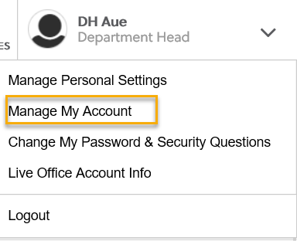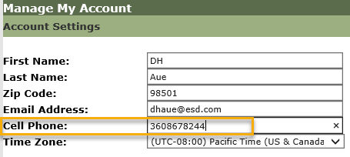

  - Create an ETO Participant record by staff so you can record services – on hold, implementation date TBD
- Tickets into production – nothing this week
- ETO maintenance – Late night and early morning of October 17 & 18. We don’t expect any interruption to service delivery. Submit a remedy ticket if you experience issues
- Velaro maintenance – 10/16/20 approximately 1 hour @ 3:30am. Maintenance will not interrupt service delivery. Submit a remedy ticket but if you hear of issues
- Training issue(s) of the week –
  - Please: Submit remedy tickets for all work requests. My team cannot begin work without a service request. Reaching out to us directly can affect the time it takes to resolve your issue. Thanks!
- ETO Engage Survey – Work on desk aid/training materials is on hold at this time
- What’s new on WPC – nothing this week
- ETO Basic and Refresher Training
  - ETO Basic training is the 1st Monday 10-12 and 3rd Tuesday 2-4 of every month (except holidays). Send email to Lynn Aue to receive more information, training account if needed and be added to the training Webex call. Invites should not be forwarded.
  - Training recordings and user guides are posted on the WPC website here https://wpc.wa.gov/tech/ETO-refresher-training
  - Submit a remedy ticket asking Lynn Aue for additional training opportunities and training resources
- Open discussion –
  - How do you get participants signatures in this virtual environment we are in?
    - By proxy: ask the customer if you can sign on their behalf. This process is not recommended for all programs and service provision. Check with your Program Operator or your supervisor for guidance.
    - Docusign. Many offices report using this. Check with your Program Operator or your supervisor for guidance.
    - Jotforms. Many offices report using this. Check with your Program Operator or your supervisor for guidance.
    - Cognito Forms. Many offices report using this. Check with your Program Operator or your supervisor for guidance.
- WSWA Virtual services to assist job seekers/employers to sharpen skills. There are many tools on WSWA but here are a couple of my favorites!
  - Check out these virtual classes under Resources>Training and other programs.
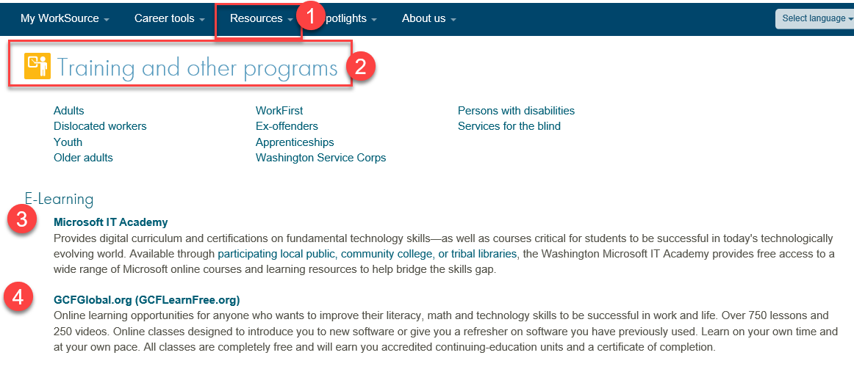
- UI announcements –
  - Proclamation: Optional job search extended through 11/8
  - Other extensions: Waiver on wait week for UI benefits and no charge against benefits for employers who use the Shared Work program
During the week of September 27 through October 2, there were 15,496 initial regular unemployment claims (down 4.6 % from the prior week) and 506,708 total claims for all unemployment benefit categories (down 4.5% from the prior week) filed by Washingtonians, according to the Employment Security Department (ESD).
  - Initial regular claims applications remain at elevated levels and are at 157 percent above last year’s weekly new claims applications.
  - Regular Unemployment Insurance, Pandemic Unemployment Assistance (PUA) and Pandemic Emergency Unemployment Compensation (PEUC) initial claims increased over the previous week.
In the week ending 10/3/20 ESD paid out over $162 million for 328,216 individual claims
- ESD.wa.gov or ESD Facebook page for current UI information
- Before submitting a service ticket help
Old Business
- Encourage all staff who use ETO and WSWA to sign up for the T12 calls. These calls are not just for trainers but for all system users and a great way to stay up to date on changes or improvements to ETO and WSWA. Send requests to esdgpWSSteam@esd.wa.gov to be added to the ITSD Training Team’s distribution list
- WorkSource Systems resources found on the WPC Technology site https://wpc.wa.gov/tech
  - We try our best to make sure all the links are operational but depend on you to submit a remedy ticket if you find broken links!
- Stay up to date on COVID19, teleworking and WorkSource Virtual services. Check out the information the WPC website to help all WorkSource staff telework.
  - IT service delivery
  - WebEx
    - Browse the Webex handbook and watch 5 videos on how to make the most out of this tool for conducting meetings with staff and customers.
  - Other resources include:
    - Now that you are teleworking reference guide
    - How to use SKYPE for online meetings
    - How to sign into ESD email from outside the network
    - How to sign into an off-site Wi-Fi from your computer
    - Can I access Internet Explorer from a MAC computer?
    - ESD service Desk information.
- UI Fraud help
  - www.esd.wa.gov/fraud
  - Fax information to claims centers 833-572-8423 –calling is not recommended due to the high volume of calls
  - Reviewing our web resources with them. Some helpful pages include:
- Employee FAQs
- Employee instructional videos
- How to file weekly claims
But you CAN’T help by:
  - Contacting an intake agent at the claims center and asking them to review your friend or family member’s claim or solve their issue.
  - Using your influence to move your friend or family member’s claim up the queue to be processed faster.
  - Using your influence to give any kind of advantage to your friend or family member.
  - Using your access to UTAB, if you have it, to give someone information about their claim.
  - Using your friend or family member’s SAW account and applying for benefits or submitting their weekly claims for them.
- Cisco Softphones training material Link http://insideesd.wa.gov/services/it-services
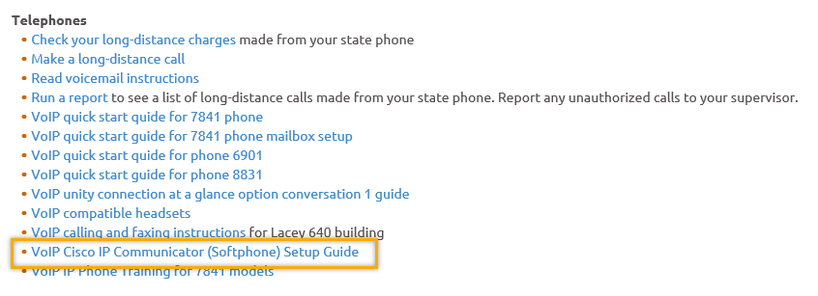
- Before submitting a service, request review these suggestions as the services desk will ask you to run through these steps. Many times, this resolves your issue without a service request!

  - Remember to log out of ETO, clicking off the browser tab here does not end your ETO session and will create issues when you log in again.
      - Always logout by opening your profile menu and clicking “Logout”
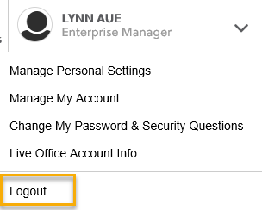
  - If you were impersonating a seeker or recruiter from ETO to WSWA remember to end the session, found in the upper left-hand corner. Clicking off your internet browser tab does not end impersonation!
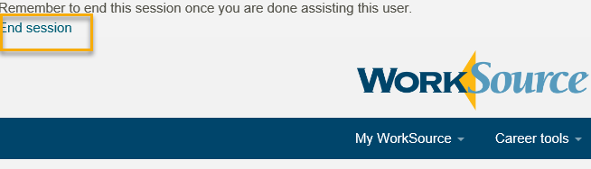

- For best performance clear your cache weekly

  - Internet Explorer (IE): Clearing IE cache starts from the top right side of the browser bar, click the settings icon and select Internet Options
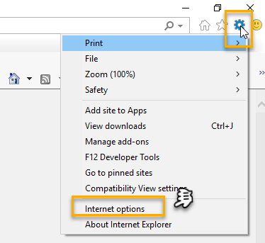

    - From the “General” tab click “Delete” which takes you to the “Delete Browsing History” screen. If not already checked click on the 2 boxes outlined here and click “Delete” you will return to the “General” tab

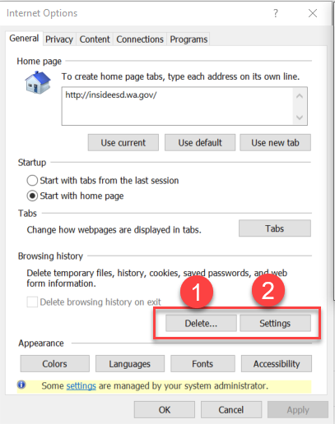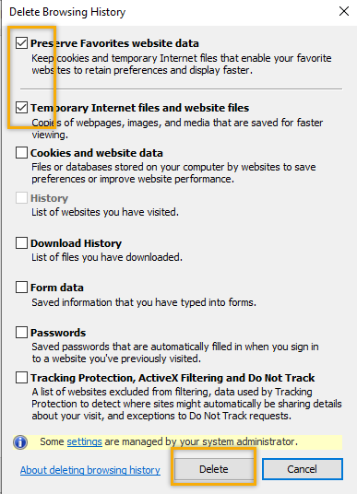

    - Next click “Settings” and if not selected click the radio button for “Every time I visit the webpage” This ensures you are using the most up to date version of ETO. Click OK
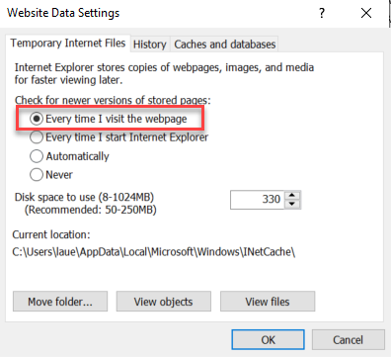
      - You will return to the General tab and click Apply and OK to complete the process of clearing your cache

  - Clearing Chrome cache starts from the top right side of the browser bar
- Click the triple dots to open the Chrome tools menu
- Hover over “More tools”
- Click “Clear browsing data” which opens a new screen
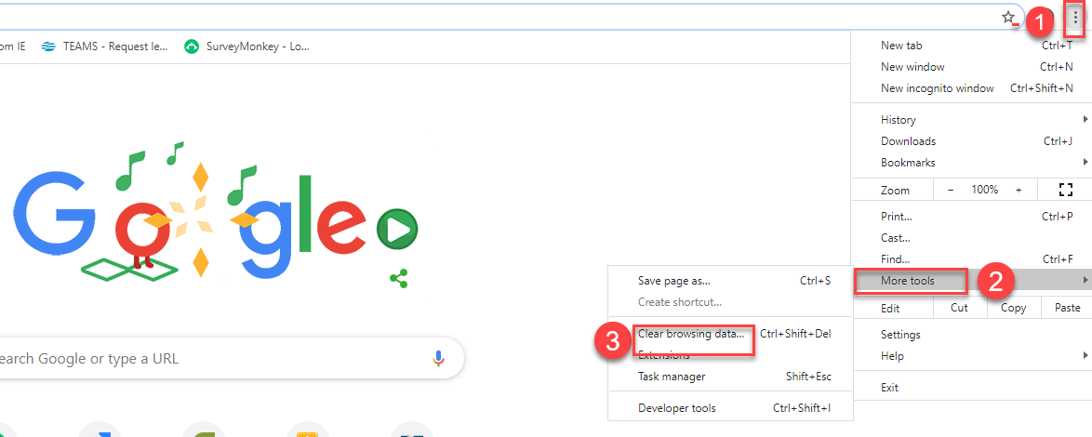

- Click “Clear data”
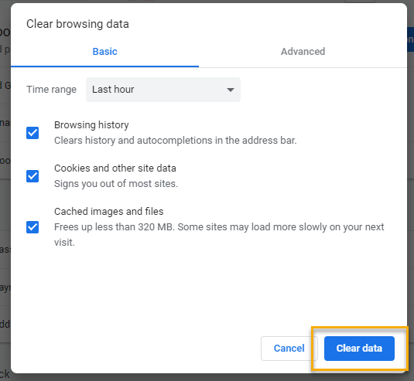

  - Finish by restarting your computer
  - If you still experience issues submit a service request https://wpc.wa.gov/tech/issues
CHAT
Regarding Basic ETO Training:
from Michael Ensor to everyone: 10:12 AM Will the traiing be segmented? I would like refresher trainign on a few things, but I don't need to go over everything again.The basic training is intended to train staff on basic ETO functionality and fulfill Policy 2010 requirement for training before granting access to ETO. During training this is emphasized and trainee’s are directed to their Program Operators and local SME’s for program specific training.

from Elizabeth Ibanez to everyone: 10:17 AM
Please, I would like to learn about how to run reports...Please see the training material on the wpc website here: https://wpc.wa.gov/tech/ETO-refresher-training (see 11-14-19 video) I am open to additional report training if you send me suggestions. We are currently working on report(s) improvments so stay tuned for updates

Regarding sharing and digitally signing documents:
from Janice Herrin to everyone: 10:15 AM
If we enroll someone to WIOA virtually; how do we get their signature?
from Aaron Parrott to everyone: 10:17 AM
Janice, many areas are using online or emailable forms with digital signatures, such as Docusign or Jotform.
from Catherine Geddis to everyone: 10:18 AM
I did a new user training last week and watched video day before (as a refresher to me). It was very helpful
from Teresa Sparks to everyone: 10:18 AM
Janice, I do know that there is a team working on docusign.
from heidi.schauble to everyone: 10:19 AM
In Snohomish County we purchased Cognito Forms- it is secure and allows uploads and signatures.
from Janice Herrin to everyone: 10:19 AM
Thank you
from Noel Woods to everyone: 10:20 AM
IN SW we use Docusign
from Catherine Geddis to everyone: 10:20 AM
Love it...Cognito
from Teresa Southard to everyone: 10:20 AM
Share please
from Becky Smith to everyone: 10:20 AM
Columbia Basin uses Jotforms
from Adeline Kerns to everyone: 10:21 AM
Is everyone goining to be using Docusign
from Aaron Parrott to everyone: 10:21 AM
Adeline, it's on a local area basis
from Ton Nguyen to everyone: 10:21 AM
We will not be using Docusign in Snohomish County
from Aaron Parrott to everyone: 10:22 AM
North Central started out with DocuSign but we moved to Jotform for ease of participant use
from heidi.schauble to everyone: 10:22 AM
We purchased both Docusign and Cognito, but so far Cognito has removed the need to use Docusign.
from Craig Clark to everyone: 10:22 AM
PacMtn is also utilizing JotForm for many applications.
from Janice Herrin to everyone: 10:22 AM
Thank you
from Aaron Parrott to everyone: 10:26 AM
I'm the form builder and admin for JotForm for North Central title I - if you have questions feel free to email me aaronp@skillsource.org
from Elizabeth Ibanez to everyone: 10:32 AM
Thank you Lynn!

Regarding submitting Remedy tickets
from Teresa Anda to everyone: 10:20 AM
Regarding Remedy tickets, if an issue has multiple problems, do you want us to enter a ticket for each problem? For example, the enrollment report is not showing demographic information (gender, ethnicity, employment status, etc.) Should I submit a remedy ticket for each item or just one ticket including all the errors? Thanks!
Submitting a ticket in the first place is the best start, and creating extra tickets is less of a burden for our team than not having any tickets at all. Generally, you’d want multiple tickets if there are multiple different issues that would not be necessarily resolved in the same action or timeframe by the WIT team. More importantly though, is that as much information is provided as possible to help us understand the issue you’re running into (screenshots, seeker/employer name(s) and case ID, steps taken that resulted in error, etc.)

ATTENDEES
Aaron Parrott
Abigail Taft
Adeline Kerns
Adelp
Amy
Arturo Espinoza
Barry Dickerson
Boliveri
Brent Arbes
Carolyn Holmes
Catherine Geddis
Christopher File
Cori Ching
Craig Clark
Crystal Armitage
Dan Cooling
Dean Coxford
Deanna Gillis
Diane Castro
Donna Mack
Dorothy Rocha
Eileen Boylston
Elizabeth Ibanez
Emiline Pahulu
Gracie Troncoso
Heidi Lamers
Heidi.schauble
Hope Baker
Ione Turner
Irene Jordan
Janice Herrin
Kate Hesseltine
Katy Stevick
Kimberly Newkirk
La Qwana
Lisa Pietkauskis
Lux Dmitri
Lyla Dinguss
Maria Zaragoza
Mauricio Kenny
Mei-Ling Taylor
Melisa Flores-Sanchez
Michael Ensor
Mirayia Chacon-Baker
Mitch McGeary
Monique Martin
Nelva March
Noel Woods
Pamela Noll
Payton Dorothy
Petru Mihaluta
Pochi Ostergren
Robbin Gard
Talia Ni Dufaigh
Teresa Anda
Teresa Southard
Teresa Sparks
Timothy Mallon
TLarson
Ton Nguyen
Toni Burow
Tracy Ferrell
Vdamneun
Victoria.wood
Young Suh
Zoryana Bilous

Second Half Attendance

