T12 Meeting Minutes 2-26-2020
New Business
- New/vs Old business
  - In consideration of your time, each week we will walk through the new business first.
  - There will be time for open discussion after new business.
  - Those who want to sign off after open discussion can leave the meeting.
  - There will be time for open discussion during old business.
  - This message to the email sent out with the agenda information each week.
- Tickets into production –
  - WA-3668 – Measurable Skills Gains report – is located under Operational Reports. The report allows users to select a WDA and enter the date range in which the TP was entered. It does not run based on the progress report date, or test date, it’s based on the date you recorded the TP. After exporting it to Excel you can then filter by office or staff member.
  - The desk aid is attached to the minutes
- Reported issue fixes in the works–
  - WA-3691 Seekers Served by Office report totals don’t display correctly. Still working on this
  - WA-3693 Staff are unable to edit job postings through recruiter impersonation. Monster plans to fix this during a scheduled release on March 12, 2020. Until then we have identified a work around. Changing the wage to a range allows you to move to the second page.
- ETO Maintenance – Nothing this week
- ETO Improvements – Nothing this week, waiting for the governance process implementation
- Training issue(s) of the week – Nothing to report
Old Business
- Data Clean-up reminder
  - We need your help with cleaning up the data in ETO. We will discuss these clean-up efforts at the Advisory meeting and report out at the T12 meetings as we continue our efforts of cleaning up ETO data before migrating data to the new system
- We are seeking ideas for ETO Improvements
  - ETO improvement ideas or current work arounds should be submitted through the remedy ticket system.
  - Tickets are reviewed to determine if idea or work around is a training issue or needs to go through the governance process for a system change
  - Submit remedy ticket here https://wpc.wa.gov/tech/issues
- ETO Refresher Training
  - Training recordings and user guides are posted on the WPC website on the Technology tab>ETO Training Resources
  - Contact Lynn Aue directly at laue@esd.wa.gov for additional training opportunities and training resources
- WorkSource Systems resources are found on the WPC Technology site
  - https://wpc.wa.gov/tech
  - We try our best to make sure all the links are operational but depend on you to email us if you find broken links!
- Encourage office staff who use ETO and WSWA to sign up for the T12 calls. These calls are not just for trainers but for all system users and a great way to stay up to date on changes or improvements to ETO and WSWA. Send requests to esdgpWSSteam@esd.wa.gov to be added to the ITSD Training Team’s distribution list
- Before submitting a service request review these suggestions:
  - What internet browser are you using?
    - Edge vs Internet Explorer?
    - Remember, only Internet Explorer gives you the best ETO experience. ETO system requirements are: Hardware Compatibility Customer Management software runs on Windows computers and is not compatible with Apple computers unless configured to operate Windows. To prevent potential issues, Windows updates should be conducted on a regular basis. It is recommended that the computer is setup to receive automatic updates for Windows.
    - Software Compatibility: Customer Management software is accessed through the internet. It is highly recommended that Internet Explorer (IE) be used as the browser for the WorkSource solution. Customer Management software is only compatible with Internet Explorer versions 9, 10 and 11. Other browsers, such as other versions of IE, Firefox, Google Chrome, Safari, may appear to function properly, but the feature may not function or save properly. Some features are browser neutral and can be accessed in Safari on the iPad as a mobile option.

  - Log out of ETO, don’t click off the tab here Your ETO session will still be active. Always logout here
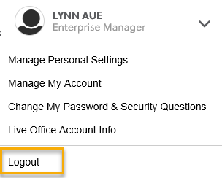
  - If you were impersonating a seeker or recruiter remember to end the session. Clicking off the browser tab does not end impersonation!
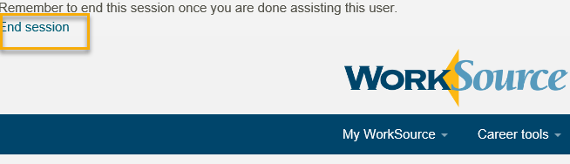

  - Restart your computer
  - Clear your cache weekly for best performance
    - From the top of your browser click the Settings icon and then select Internet Options
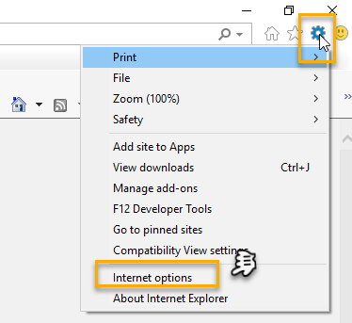

    - Click Delete on the General tab which takes you to the Delete Browsing History screen. If not already checked click on the 2 boxes outlined here and click delete
    - You will return on the General tab where you click Apply and OK to complete the process of clearing your cache

CHAT Nothing to report

ATTENDEES

Aaron Parrott
Abigail Taft
Amyxg
Arthur
Barbara
Becky Smith
Brett
Claire B
Don Cooling
Dawn Oaks
Dean Coxford
DMack
Dorothy Rocha
Drhamilton
Emily Anderson
Heidi Lamers
JJordan
Joanie Linder
Jordan Meyenburg
J Sutton
Katherine C
Katy Stevick
Lisa Pietkauskis
Maria
MDominguez
Melissa Robinson
Petra Barba
Rebecca McGinnis
SButler
SGates
Slatiff
TASparks
Teresa Anda
Toni Burow
TSouthard

