T12 Meeting Minutes 3-11-2020
New Business
- COVID19 updates
  - Creating desk aids to post on WPC website to help staff work from home. Will notify you when posted on WPC
- Tickets into production – nothing this week
- Reported issues/fixes in the works–
  - WA-3704 Intermittent issues with ETO time out
    - The current issue is caused by a timeout feature used by some customers. It was turned on for all ETO customers March 2019. The vendor’s developer is working on turning this additional time out feature off for Washington users.
- ETO Maintenance – Upcoming, nothing to report now
- WSWA Maintenance - WSWA site will be down for maintenance this weekend: Friday, March 13th @ 10PM PT – Saturday, March 14th @ 3AM PT. A banner will be placed on the website Friday mid-morning and removed when the internal QA testing is complete.
- ETO Improvements –
  - Report performance improvements tickets closed
    - Seekers served by Office 53%
    - Program Enrollment Outcomes 27%
    - Case Management Report 47%
    - Individualized Training and Support Services TP’s 55%
    - Case Notes 4.0 Optimized 87%
    - Case Notes 4.0 (No Wit Integration) Optimized 87%
  - Reports still in progress
    - Ex-Offender With or Without a Basic Services or ITSS Optimized - working on issues with report
    - RESEA Seekers Served Optimized 0% due to adding email addresses– waiting for response from RESEA staff
    - Program Enrollment Report with Demographic Details Optimized – working on issues with report
    - SeekersbyServiceDraft Optimized 92% - asking T12 to test and report out to Lynn
    - Veterans Case Management Optimized 17% – reaching out to Vets staff for testing
    - Seeker Summary – still working on issues with report
    - DVOP Services Optimized 56%– reaching out to Vets staff for testing
    - Local Reporter Services Report Optimized 86%– asking T12 to test and report out to Lynn
  - ETO browser neutrality coming soon
    - SSG has announced that browser neutrality is coming in June 2020. This will allow you to use Chrome and other browsers for ETO
- Training issue(s) of the week –
  - Internet settings – process now included under Old business section of what to do before submitting remedy ticket or calling service desk
  - Confidential Case notes – Response ID is hidden and the “No Data to Retrieve” message means there aren’t case notes in the fields identified. This is not an error message
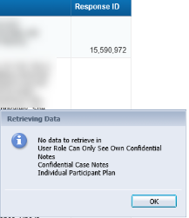

  - Who can delete Program Enrollments and Services?
    - Department Heads. It is a data integrity conflict for the WSS team to delete or correct data
Old Business
- Data Clean-up reminder
  - We appreciate your help with cleaning up the data in ETO as we continue our efforts to clean up ETO data before migrating it to the new system. Clean-up efforts are discussed and approved at Advisory meetings and then reported out at the T12 meetings.
- We are seeking ideas for ETO Improvements
  - ETO improvement ideas or current work arounds should be submitted through the remedy ticket system.
  - Tickets are reviewed to determine if the idea or work around is a training issue or needs to go through the governance process for a system change
  - Submit remedy ticket here https://wpc.wa.gov/tech/issues
- ETO Refresher Training and other WS Systems resources
  - Refresher Training recordings and user guides are posted on the WPC website under the ETO Training Resources section https://wpc.wa.gov/tech
  - Contact Lynn Aue directly at laue@esd.wa.gov for additional training opportunities and training resources
  - We try our best to ensure all the links are operational but depend on you to email us if you find broken links!
- Encourage office staff who use ETO and WSWA to sign up for the T12 calls. These calls are not just for trainers but for all system users and a great way to stay up to date on changes or improvements to ETO and WSWA. Send requests to esdgpWSSteam@esd.wa.gov to be added to the ITSD Training Team’s distribution list

- Before submitting a service request review these suggestions as the services desk will ask you to do this and many times this resolves your issue more timely:
  - What internet browser are you using?
    - Edge vs Internet Explorer?
    - Remember, only Internet Explorer gives you the best ETO experience. ETO system requirements are: Hardware Compatibility Customer Management software runs on Windows computers and is not compatible with Apple computers unless configured to operate Windows. To prevent potential issues, Windows updates should be conducted on a regular basis. It is recommended that the computer is setup to receive automatic updates for Windows.
    - Software Compatibility: Customer Management software is accessed through the internet. It is highly recommended that Internet Explorer (IE) be used as the browser for the WorkSource solution. Customer Management software is only compatible with Internet Explorer versions 9, 10 and 11. Other browsers, such as other versions of IE, Firefox, Google Chrome, Safari, may appear to function properly, but the feature may not function or save properly. Some features are browser neutral and can be accessed in Safari on the iPad as a mobile option.

  - Log out of ETO, don’t click off the tab here Your ETO session will still be active. Always logout here
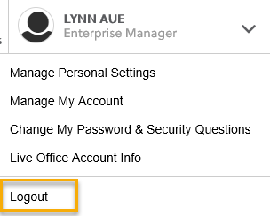
  - If you were impersonating a seeker or recruiter remember to end the session. Clicking off the browser tab does not end impersonation!
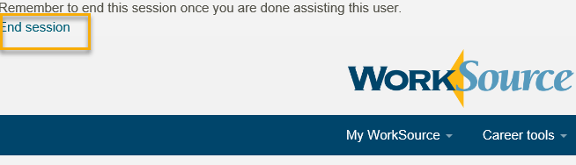

  - Clear your cache weekly for best performance and check your Internet Settings.
    - From the top of your browser click the Settings icon and then select Internet Options
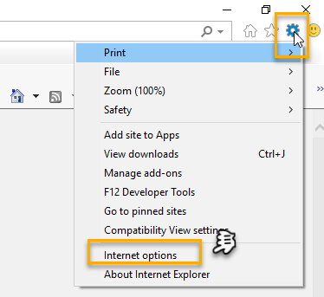

- Begin by clicking Delete on the General tab which takes you to the Delete Browsing History screen. If not already checked click on the 3 boxes outlined here and click delete
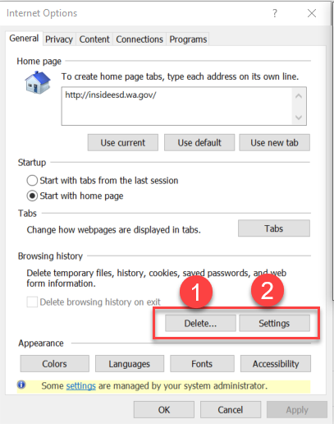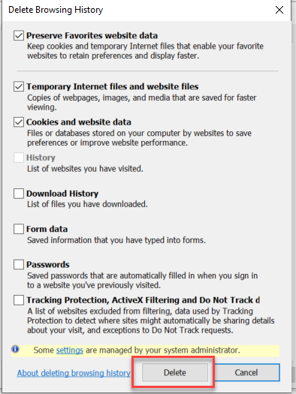

- Next click the Settings tab to ensure you will be using the most up to date version of ETO and click OK
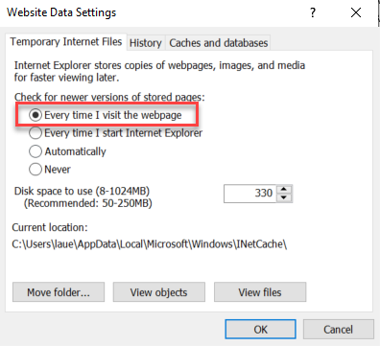
    - You will return to the General tab and click Apply and OK to complete the process of clearing your cache
  - Restart your computer
CHAT
Is there written guidance on Opt-ing in job seekers for non ESD staff? There is not written guidance from ITSD. I suggest you contact ES’s Policy unit and ask them for it here: ESAP Team Mailbox - SystemPolicy@ESD.WA.GOV
sgates: Will ETO work on Mac computers? Yes, but this time, ETO is Internet Explorer dependent. If you run an internet search for How to run IE on a Mac computer there are many resources out there.
Brooke Zielinski: When deleting a program enrollment and/or services do we need to include a screen shot of the deleted services? From the Monitoring Team: No screenshot needed, just a case note for the reason for changes or backdating services in regards to noncompliance for WIN0082

ATTENDEES
Abigail Taft
Becky Smith
Brett
Brook Zielinski
Chris File Claire B
Craig Clark
C Shaffer
Dean oxford
Donna Hendrickson
Donna Mack
Dorothy Rocha
Emily Anderson
Epahulu
Heidi Lamers
I Jordan
Joanie Linder
Jordan Meyenburg
Katherine C
Lisa Pietkauskis
R Cancel
Rebecca McGinnis
RJonas
S Butler
Selam Tekle
S gates
Tiffany Grannillo
TRobinson
VDamneun

