T12 Meeting Minutes 1-29-2020
New Business
- WA-3660 WSWA doesn’t allow decimal point when entering wages into job postings
  - This was put into production 1-21-2020
- Tickets into production –
  - WA-3641 Added Local program as option for Follow-up TP
    - Local programs and Contracts are not mapped to federal reporting (see more under training issue(s) of the week)
  - WA-3642 Self Service job searches now are being attributed to the correct office or show up as Administration if it is a self-service activity
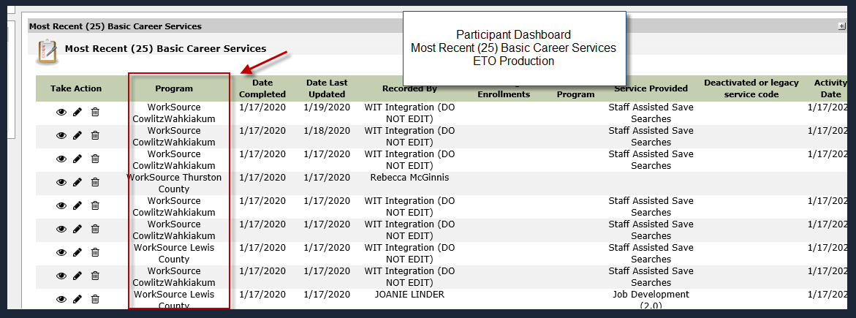

- ETO Improvements – Nothing this week
- We are seeking ideas for ETO Improvements
  - ETO improvement ideas or current work arounds should be submitted through the remedy ticket system.
  - Tickets are reviewed to determine if issue or idea is a training issue or need to go through the governance process for system change
- Training issue(s) of the week
  - Rapid Response Increased Employment (RRIE) Program of Enrollment vs Local Program/Contracts
    - Some local areas create a Local Program or Contract enrollment for RRIE that includes a program year and WDA call out. This is up to your local area. However you must enroll participant’s into the RRIE statewide program for federal reporting. Contact your local supervisor, trainer or MIS person for more information on your local practice
  - Adding an office to ETO
  - Before submitting service request
    - What internet browser are you using?
    - Edge vs Internet Explorer? Remember, only Internet Explorer gives you the best ETO experience
  - Log out of ETO, don’t click off the tab here Your ETO session will still be active. Always logout here
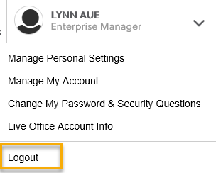
  - If you were impersonating a seeker or recruiter remember to end the session. Clicking off the browser tab does not end impersonation!
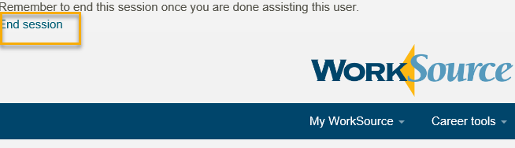

  - Restart your computer
  - Clear your cache weekly for best performance
    - From the top of your browser click the Settings icon and then select Internet Options
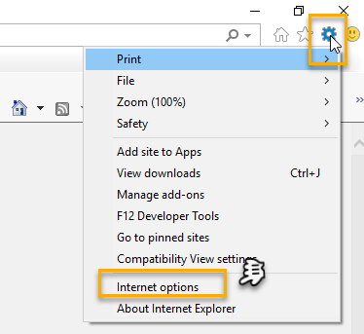

    - Click Delete on the General tab which takes you to the Delete Browsing History screen. If not already checked click on the 2 boxes outlined here and click delete
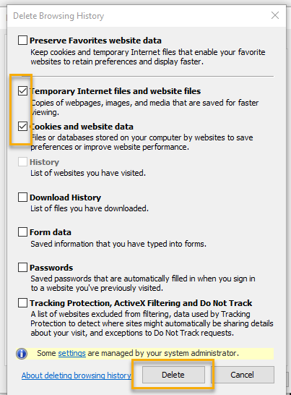

    - You will return on the General tab where you click Apply and OK to complete the process of clearing your cache

- 2-5-2020 T12 all user call is cancelled

Old Business
- Data Clean-up reminder
  - We need your help with cleaning up the data in ETO. We will discuss these clean-up efforts at the Advisory and report out at the T12 meetings as we continue our efforts of cleaning up ETO data before migrating data to Phoenix
- ETO Refresher Training
  - Past trainings were recorded. The recordings and user guides are posted on the WPC website on the Technology tab>ETO Training Resources
  - Contact Lynn Aue directly at laue@esd.wa.gov for additional training opportunities and training resources
- WorkSource Systems resources are found on the WPC Technology site
  - https://wpc.wa.gov/tech
  - We try our best to make sure all the links are operational but depend on you to email us if you find broken links!
- Encourage office staff who use ETO and WSWA to sign up for the T12 calls. These calls are not just for trainers but for all system users and a great way to stay up to date on changes or improvements to ETO and WSWA. Send requests to esdgpWSSteam@esd.wa.gov to be added to the ITSD Training Team’s distribution list

CHAT
Maria:
Is there a possibility to add a column that allows us to customize the service provided…ie In ITS touchpoints it has the ‘identifier’ as a number and the ‘Service Provider’ shows ‘Support Services – Fees, Supplies, Test, Transportation, etc.’ We would find it very helpful if we had the ability to add a specific identifier such as ‘Transportation-Feb bus pass’. Currently we are double case entering because we can find things easier in case notes, than in touch points.
This might be an ETO improvement. Please submit a remedy ticket so we can look into it!

ATTENDEES
Joanie Linder
A Clemons
A Hughes
AKerns
Amy
Arthur
Barbara
Brett
BWarbes
BZielinski
CBrittain
Chris File
Craig Clark
C Sivewright
Dawn Oakes
Dean Coxford
Diane Luoma
DMack
Donna Hendrickson
Eileen Boylston
Emily Anderson
Heidi Schauble
Ismaila Maidadi
Jordan Meyenburg
Josh Sutton
Jpenny Cook
Katherine C
Katy Stevick
Lisa Pietkauskis
Luci
Maria
Melissa Robinson
MoMartin
Nesparza
postergren
Rudy Anaricio
SButler
Scher
skeltner
Slatiff
Teresa
Toni Burow
Tracy ferrell
Vdamneun
Zoryana Bilous

