How to log onto WorkSource resource or training room computers
- Start by clicking any key on the keyboard to open a session

- Read the warning message, click Ok
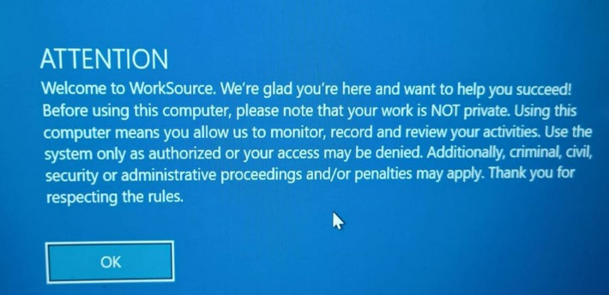

- Click Guest icon
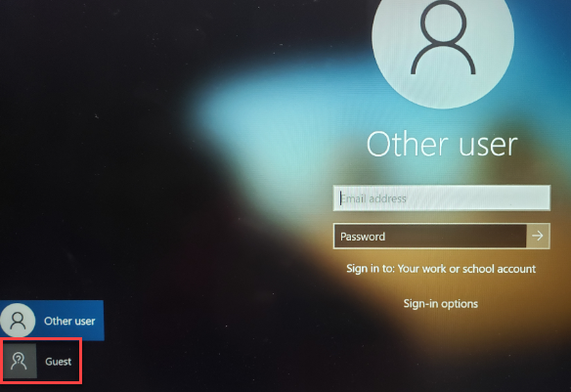

- Click Sign in and land on the Employment Security Department (ESD) home page.

- Click the Google Chrome icon to open the WorkSourceWA app where you can create or sign into an account, create resumes, search, and apply for jobs, connect with employers and check out other features designed to help you make important career decisions.
- Desktop computers marked with a green dot have Microsoft Office installed on them. This allow you to work on Word, Excel or PowerPoint documents and save them to a USB portable device.
- Desktops and laptops without a green dot do not have Microsoft Office installed on them. However, all computers have the ability to go online and sign up for free productivity applications provided by Microsoft and/or Google to perform work tasks and save documents in a third-party cloud-based solution.
- Check out GCFGlobal.org for learning opportunities to improve literacy, math, and technology skills to be successful in work and life. Over 750 lessons and 250 videos including help with Microsoft and/or Google account creation and using their free tools.
Important: Public use computers are set to lock after 15 minutes of inactivity, so save your work frequently to avoid losing it.

To protect your personal data always restart the public-use computer when leaving the computer unattended or after finishing your work. Locking the computer will log you off.
- Click the Windows Start icon
- Click the power icon
- Click Restart
- Shut down. Never shut down a public-use machine. They need to always be on to receive updates.
