T12 Meeting Minutes 2-24-2021
Remember: After starting a Webex meeting to mute your audio and disable the video feature. Too many attendee’s with active video can interfere with everyone’s audio quality. Hover over the lower edge of your monitor screen to find the icons.

Thanks to all who contribute to this weekly call!

New Business
- Tickets into production –
  - WA-4089 changes to LNI program in the “Other Program” category
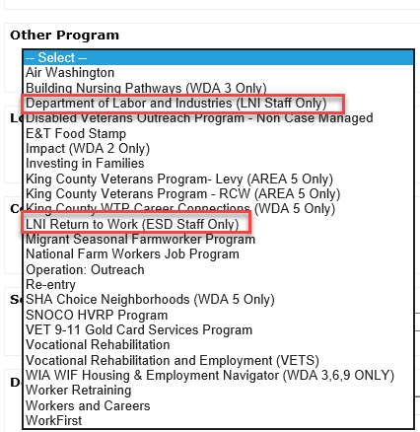
- ETO maintenance – Release 2/25/21. We don’t anticipate any issues from this system updates, but if you notice strange behavior submit a remedy ticket including detailed information and screen shots so we can trouble shoot and resolve.
- To increase system security, changes to ETO password requirements will begin March 1, 2021. The first time you change your password after March 1, 2021, you will need to select a password that is at least 12 or more characters. Notification was sent out via ETO messaging 2/12/2021 and to the T12 2/17/2021
  - The password needs to contain the following;
    - A capital letter,
    - A lower-case letter,
    - A number and,
    - A special character such as; ? ~ ! @ # $ % ^ * ( or )
- WSWA maintenance – n/a
- Velaro maintenance – 2/26/21. We don’t anticipate any issues from this system updates, but if you notice strange behavior submit a remedy ticket including detailed information and screen shots so we can trouble shoot and resolve.
- ETO Engage – The additional information to the survey is in and we are in the process of creating the training material.
- ETO Basic and Refresher Training - Next training is on 3/1/21 10-12
  - ETO Basic training is the 1st Monday 10-12 and 3rd Tuesday 2-4 of every month (except holidays). Send email to Lynn Aue to receive more information, training account if needed and be added to the training Webex call. All ETO/WSWA system users are welcome to attend the training but please do not forward invites as I need to review all attendees and assign training accounts if needed.
  - Training recordings and user guides are posted on the WPC website here https://wpc.wa.gov/tech/ETO-refresher-training
  - Submit a remedy ticket requesting additional training opportunities and resources
- What’s new on WPC –
  - Report enhancements by category
    - Job Seekers
      - Participants New to ETO; Updated report logic to pull based on date demographic details TP created; report identifies how profile created by either staff, WSWA (WIT Integration) or UTAB (UI Interface)
    - Operational Reports
      - Open Durational Services; Added new column for most recent date TP updated
    - Re-Entry Reports
      - Outreach Re-Entry Program Based on Audit Date; NEW--corrected report logic; displays data based on most recent 'audit' date
      - Outreach Re-Entry Program Based on Service Date; NEW--corrected report logic; displays data based on most recent 'service' date
      - Outreach Reentry Program; Deleted report; split into two separate versions
      - Re-Entry with Basic Services; Corrected report logic for identifying offenders
      - Re-Entry with ITSS Services; Corrected report logic for identifying offenders
    - Veterans
      - Spouse Program Eligibility Screening Questions; NEW--split spouse questions into separate report
      - Veteran Program Eligibility Screening Questions; Updated to remove spouse questions and added them to new report
- Open discussion and training issue(s)–
  - Update from last meeting; CatherineG, we have started using Caseworkers lists (consistently) in ETO. Is there any way to have last qualifying touch point entered automatically or manually? Suspect not, but I must ask just in case. In addition to start and end date option, there are fields for Caseworker Relationship and Caseload Status. At this time there isn’t a way to configure that TP to add a start and end date. We will discuss this more at the next meeting.
  - Job Seekers>Service Planned End Date report? The current report logic is limited to only show participants who have the user running the report on their caseload during the timeframe selected. We will hide this report for now
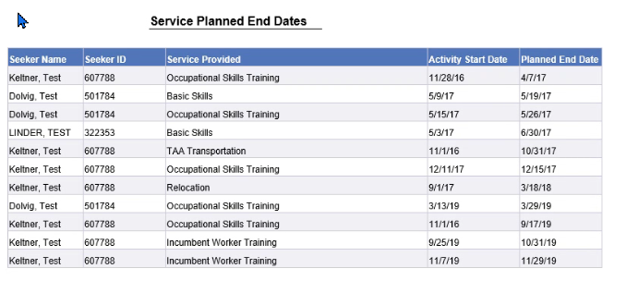
  - What report(s) do you use to case manage service(s) planned end dates?
    - Teresa Anda - the services report (Local Reporter category)
    - Tim Robison - Local Reporter Services Report
    - Toni Burow - Individualized Training and Support Services report
    - Emily Anderson - I would really recommend surveying users since many of the data folks do not attend the T12 calls.
      - Thanks to everyone for weighing in on this. Emily, Mary is on it!
  - Mary; Three NEW Program Enrollment reports. Slimmed down without Demographic details, slimmed down w/demo details and the original report with unnecessary fields removed.
    - Aaron Parrott - That is gonna make quick program counts a dream
    - Mary MacLennan - I'm hoping to start working on these changes today!
    - Mary MacLennan - @Aaron - glad the changes will help!
  - Toni Burow - is there a report that shows when a touchpoint has been updated or last touched? Submit remedy ticket for review of this potential new report.
  - Teresa Anda - Can we have an eligibility tp report that shows demographic information? This can help before enrollment is done. Submit remedy ticket for review of this potential new report.
  - Emily Anderson - I can help work on reports

Reminder: Submit remedy tickets for all work requests. The WSS team cannot begin work without a service request. Reaching out to us directly can affect the time it takes to resolve your issue. Thanks! https://wpc.wa.gov/tech/issues
- UI announcements –
OLYMPIA – During the week of February 14 - 20, there were 14,043 initial regular unemployment claims (up 3.2 percent from the prior week) and 462,218 total claims for all unemployment benefit categories (up 3.3 percent from the prior week) filed by Washingtonians, according to the Employment Security Department (ESD).
- Initial regular claims applications remain at elevated levels and are at 155 percent above last year’s weekly new claims applications.
- Initial claims for Pandemic Unemployment Assistance (PUA) and Pandemic Emergency Unemployment Compensation (PEUC) decreased over the week while initial and continued claims for regular benefits increased over the week.
- Increases in layoffs in Construction, Agriculture and Accommodation & Food Services led the overall increase in regular initial claims last week. Regular initial claims in the Construction sector increased by 422 initial claims over the week to 2,766 total regular initial claims. Washington was one of 12 states that had increases in initial claims during the week ending Feb. 20.
In the week ending February 20, ESD paid out over $249 million for 315,508 individual claims. Since the crisis began in March, ESD has paid more than $15 billion in benefits to over a million Washingtonians.
- For current COVID-19 and UI information ESD.wa.gov or ESD Facebook page
- UI Fraud help
  - www.esd.wa.gov/fraud
  - Fax information to claims centers 833-572-8423 –due to the high volume, calling is not recommended
- Before submitting a service ticket, review this desk aid “Check list: things to try before submitting a service/remedy ticket”
- Visit this page on the WPC site to submit a service request: https://wpc.wa.gov/tech/issues If you are an ESD partner, there is a downloadable form that you must fill out and send to the Technical Solutions service desk – their e-mail is ESDDLITBITechnicalSolutions@ESD.WA.GOV
Review of ETO/WSWA and other resources (AKA old business)
- Encourage all staff who use ETO and WSWA to sign up for the T12 calls. These calls are not just for trainers but for all system users and a great way to stay up to date on changes or improvements to ETO and WSWA. Send requests to esdgpWSSteam@esd.wa.gov to be added to the ITSD Training Team’s distribution list
- WorkSource Systems resources found on the WPC Technology site https://wpc.wa.gov/tech
  - We try our best to make sure all the links are operational but depend on you to submit a remedy ticket if you find broken links!
- Check out the information the WPC website to help all WorkSource staff telework stay up to date on COVID19, teleworking and WorkSource Virtual services including;
  - IT service delivery
  - WebEx
    - Browse the Webex handbook and watch 5 videos on how to make the most out of this tool for conducting meetings with staff and customers.
  - Other resources include:
    - Now that you are teleworking reference guide
    - How to use SKYPE for online meetings
    - How to sign into ESD email from outside the network
    - How to sign into an off-site Wi-Fi from your computer
    - Can I access Internet Explorer from a MAC computer?
    - ESD service Desk information.
- Cisco Softphones training material Link http://insideesd.wa.gov/services/it-services
CHAT
Chat is included in the open discussion

ATTENDEES

Aaron Parrott
Abigail Taft
Amy
Arturo Espinoza
Barbara
Barry Dickerson
Becky Smith
Carl Peterson
Catherine Geddis
Christina Shaffer
Cori Ching
Dean Coxford
Diane Luoma
Donetta McCormack
Donna Mack
Elijah Wabnitz
Emily Anderson
Heidi Lamers
Irene Jordan
Jack Dryden
James Walker
Jo Ann Enwall
Joanie Linder
Jordan Meyenburg
Kate Hesseltine
Kellina Jones
Kendall King
Kylie Bartlett
Lisa Pietkauskis
Lux Dmitri
Maria Zaragoza
Marla McMackin
Mary MacLennan
Melisa Flores-Sanchez
Monique Martin
Phillis Hall
Regina Cancel
Robbin Gard
Robert Jonas
Shannon Booth
Matthew Shields
Skyler Blementhal
Teresa Adna
Theresa Rogers
Tim Robison
TLarson
Ton Nguyen
Toni Burrow
Tracy Ferrell
Vey Damneun
Zoryana Bilous

Attended second half

