Entering a group service into ETO
The process begins after logging into ETO and clicking Record Services (Individuals or Groups) from your dashboard
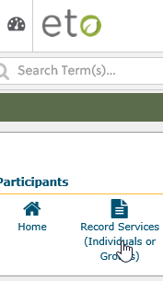
- On the next screen, click the dropdown arrow and select the type of Touch Point (TP) you want to create from the selection menu
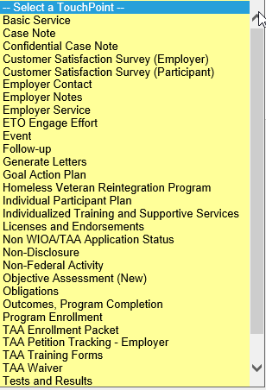
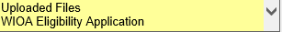
- Today we are showing a Basic Service. After selecting Participant ETO will open up the Participants list. Type in the last name and click the filter Icon to display the participant. Click the box next to the participant you want to add to your group service. After selecting all the participants click “Continue”

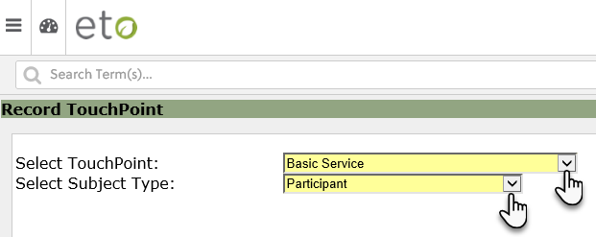

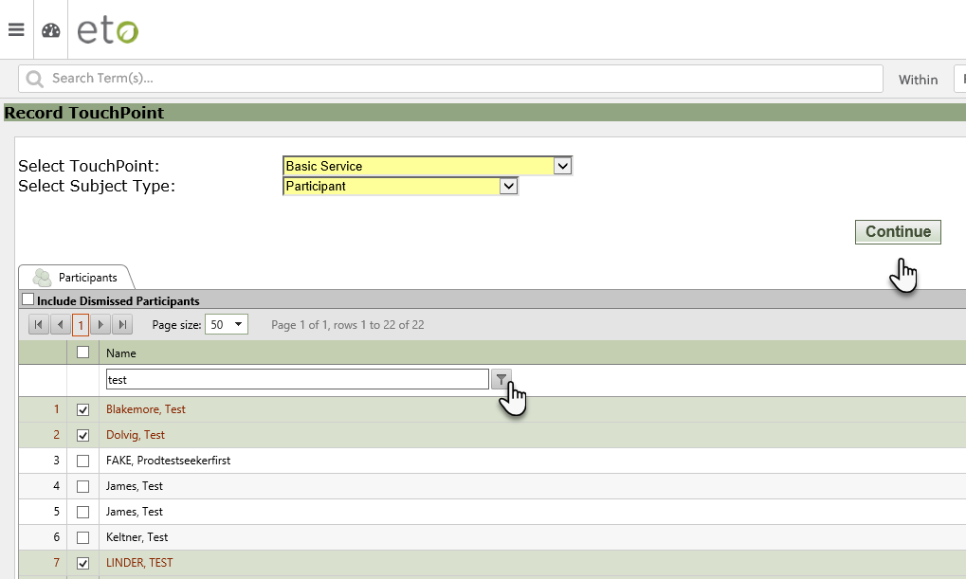

This is your collection of participants to record your group service(s) and attach active program enrollments, local or other programs and contracts.

- Record the group service by first selecting the “Service Provided” from the drop down menu and Activity Date
- If all participants have the same Contract, Local Program or Other Program add them at this time and the selection will be added to all. An Active Program Enrollment cannot be entered as a group service. OR
- You can save the service without adding an Active Program of Enrollment, Contract, Local Program or Other Program. All participants will have the same service and date of service. Remember, saving at this point will not be allow you to go back into the TP and add a program. The slide below shows all 3 participants have a basic service taken on 10/24/19 with no program enrollment or contract attached
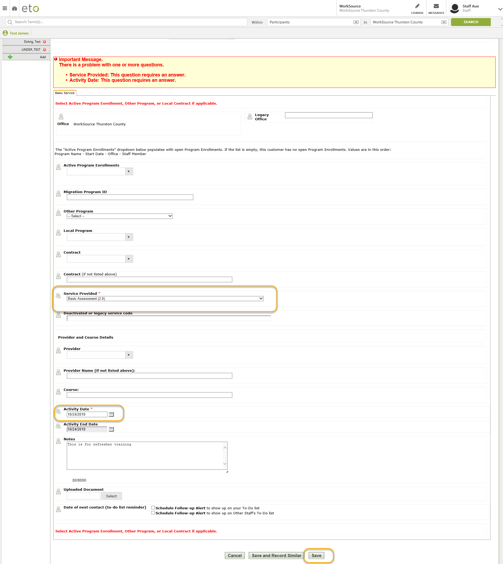
ETO Group Services and Integrated Service Delivery or Co-Enrollment
You can create group services for more than one Active Program Enrollment, Contract, Local Program, Other Program or multiple services for the same participant in your collection. This eliminates the need to create more than one collection with the same participants.

- If all participants have the same Contract, Local Program or Other Program add them after selecting the service and activity date. An Active Program Enrollment cannot be entered as a group service.
- If all participants are not enrolled into the same Contract, Local Program or Other Program you must click on each participant and select the applicable program or contract one participant at a time before clicking “Save”.
- You can only enter an Active Program Enrollment by going into each participant and entering them individually before clicking “Save”.
- The slide below shows Test Blakemore’s TP open and there are two active programs to choose from.
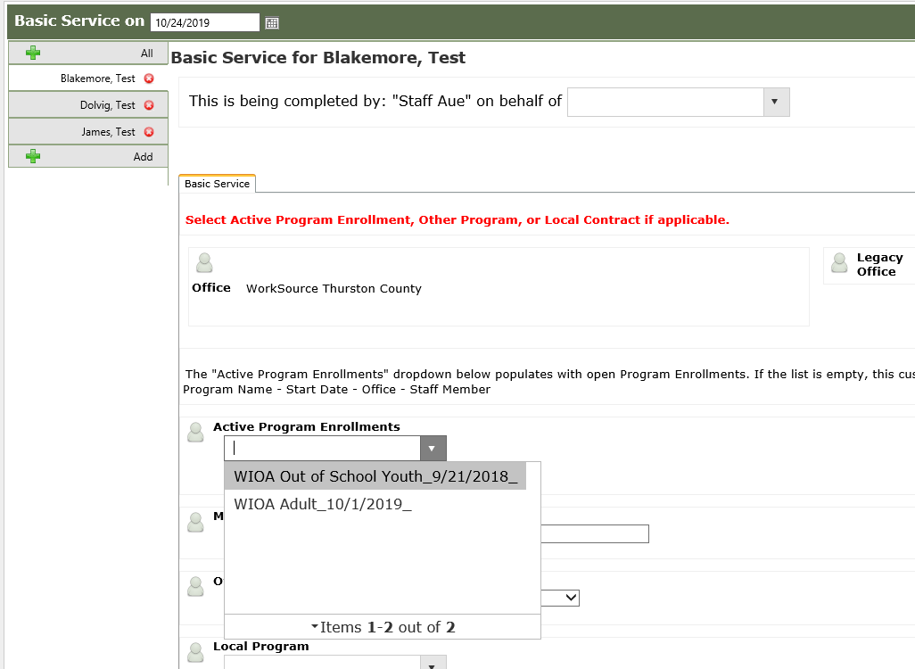
- You continue selecting each participant and adding a program or contract for this service
- If there was only one service and you updated all the participants in your collection, click “Save.”

- If you have several services or want to co-enroll click “Save and Record Similar” to create another TP for the same collection of participants.

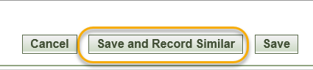

- You can add/delete participants from your group service by clicking on the + or X box. “All” selects everyone in the collection.
- You can now enter a new service, contract or other/local program, date of service for all of the participants in your ne collection or you can enter the service and then select each participant individually to enter a program or contract

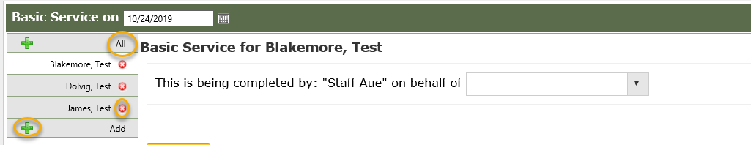

Remember
- Clicking the garbage can from Test Blakemore’s dashboard will delete everyone in the collection
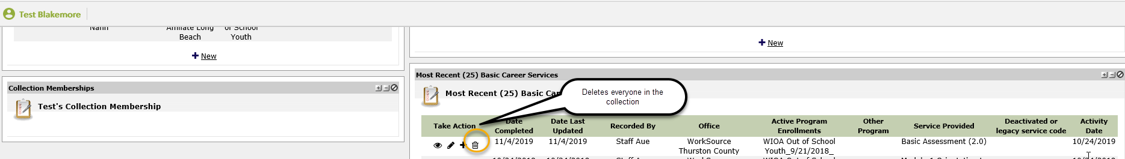
- You can delete the entire collection by clicking the garbage can on your dashboard.
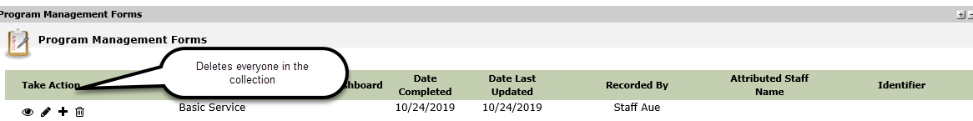
- Case notes taken as a group will only be shown in the group collection.

