T12 Meeting Minutes 1-27-2021
Remember: After starting a Webex meeting to mute your audio and disable the video feature. Too many attendee’s with active video can interfere with everyone’s audio quality. Hover over the lower edge of your monitor screen to find the icons.

Thanks to all who contribute to this weekly call!

New Business
- Tickets into production tonight– WA-4045 hide 2nd O’net code box from ITSS
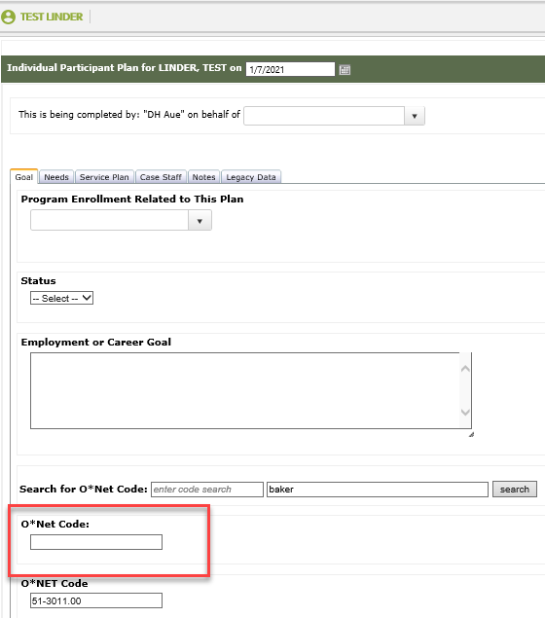
- ETO maintenance – n/a
- ETO extended maintenance window 7AM 1/23/ to 2PM 1/24/21. SSG reports this upgrade will drastically increase ETO performance for 2021. Thoughts on improvement? Consensus no noticeable improvement in performance
- WSWA maintenance – n/a
- Velaro maintenance – n/a
- ETO Engage – We continue work on the enhancement of this tool, creating training material and delivery of training.
- ETO Basic and Refresher Training Next training is 2/1/2021 10-12, class is full for new users who want to be assigned a training account. Any user can attend as a “watcher”. There is another class on 2/16/2021 2-4
  - ETO Basic training is the 1st Monday 10-12 and 3rd Tuesday 2-4 of every month (except holidays). Send email to Lynn Aue to receive more information, training account if needed and be added to the training Webex call. All ETO/WSWA system users are welcome to attend the training but please do not forward invites as I need to review all attendees and assign training accounts if needed.
  - Training recordings and user guides are posted on the WPC website here https://wpc.wa.gov/tech/ETO-refresher-training
  - Submit a remedy ticket requesting additional training opportunities and resources

- What’s new on WPC –
  - ETO Enhancements updates – Reports https://wpc.wa.gov/tech/eto_Report_Enhancements
- Open discussion and training issue(s)–
  - Issue with Program Enrollment report pulling inconsistent results – We have not done any work on this report. The tickets we received showed the issue was due to pulling the reports for a large time frame. Some were pulled for 4 years. If the date or WDA parameters are too large the report will act like it successfully ran but it actually timed out. This is why if you pull it twice you get different results as the report has cached the first instance and added more data to it the second time it ran. Please submit a ticket if you are still having issues with this or any other report in ETO.
  - Reminder: Submit remedy tickets for all work requests. The WSS team cannot begin work without a service request. Reaching out to us directly can affect the time it takes to resolve your issue. Thanks! https://wpc.wa.gov/tech/issues
- UI announcements –
Initial regular unemployment claims decreased while continued claims increased during week of January 17-23.
During the week of January 17-23, there were 16,461 initial regular unemployment claims (down 14.3 percent from the prior week) and 482,158 total claims for all unemployment benefit categories (up 2.8 percent from the prior week) filed by Washingtonians, according to the Employment Security Department (ESD).
- Initial regular claims applications remain at elevated levels and are at 107 percent above last year’s weekly new claims applications.
- Initial claims for regular unemployment, Pandemic Unemployment Assistance (PUA) and Pandemic Emergency Unemployment Compensation (PEUC) all decreased over the week.
- Reductions in layoffs in accommodation and food services and in the retail trade sector drove a decrease in new regular jobless claims last week. Regular initial claims in the accommodation and food services sector decreased by 464 claims over the week to 1,814 total regular initial claims. In the retail trade sector initial claims decreased by 318 initial claims over the week.
- Extended Benefits claims accounted for the bulk of the increase in continued claims over the week. Extended Benefits claims increased across all industry sectors over the week, with the Accommodation and Food services (+794) and Retail trade (+515) sectors experiencing the largest increases.
In the week ending January 23, ESD paid out over $234 million for 300,222 individual claims. Since the crisis began in March, ESD has paid more than $14 billion in benefits to over a million Washingtonians.
- For current COVID-19 and UI information ESD.wa.gov or ESD Facebook page
- UI Fraud help
  - www.esd.wa.gov/fraud
  - Fax information to claims centers 833-572-8423 –due to the high volume, calling is not recommended
- Before submitting a service ticket, review this desk aid “Check list: things to try before submitting a service/remedy ticket”
- Visit this page on the WPC site to submit a service request: https://wpc.wa.gov/tech/issues If you are an ESD partner, there is a downloadable form that you must fill out and send to the Technical Solutions service desk – their e-mail is ESDDLITBITechnicalSolutions@ESD.WA.GOV
Review of ETO/WSWA and other resources (AKA old business)
- Encourage all staff who use ETO and WSWA to sign up for the T12 calls. These calls are not just for trainers but for all system users and a great way to stay up to date on changes or improvements to ETO and WSWA. Send requests to esdgpWSSteam@esd.wa.gov to be added to the ITSD Training Team’s distribution list
- WorkSource Systems resources found on the WPC Technology site https://wpc.wa.gov/tech
  - We try our best to make sure all the links are operational but depend on you to submit a remedy ticket if you find broken links!
- Check out the information the WPC website to help all WorkSource staff telework stay up to date on COVID19, teleworking and WorkSource Virtual services including;
  - IT service delivery
  - WebEx
    - Browse the Webex handbook and watch 5 videos on how to make the most out of this tool for conducting meetings with staff and customers.
  - Other resources include:
    - Now that you are teleworking reference guide
    - How to use SKYPE for online meetings
    - How to sign into ESD email from outside the network
    - How to sign into an off-site Wi-Fi from your computer
    - Can I access Internet Explorer from a MAC computer?
    - ESD service Desk information.
- Cisco Softphones training material Link http://insideesd.wa.gov/services/it-services

CHAT
- Luci Bench to everyone: 10:05 AM - The Program Enrollment Report - With Demographic Details OPTIMIZED is not pulling all the same data. Has it changed? A) Submit a ticket with screen shots and report details
- Becky Smith to everyone: 10:06 AM - I'm also having problems with the Program Enrollment Report.
- vdamneun to everyone: 10:06 AM - Can we just skip ETO and start fresh with other system?
- Kylie Bartlett to everyone: 10:06 AM - Since the updates, my team cannot save WIOA eligibility applications at all. They can have they as a draft and that is it.
- Becky Smith to everyone: 10:06 AM - I'm also having problems with the Program Enrollment Report.
- Luci Bench to everyone: 10:07 AM - @Becky, have you pulled it recently? Pulled it at the beginning of the month and it was fine, but this week it's pulling only a third of the rows.
- Talia Ni Dufaigh to everyone: 10:07 AM - yes!
- Becky Smith to everyone: 10:07 AM - Today
- Luci Bench to everyone: 10:08 AM - Pulled it twice today and not pulling correctly
- Talia Ni Dufaigh to everyone: 10:08 AM - WIOA Basic was saving - But when taking a service, the WIOA Basic was not there. In Thurston, it works with Program Enrollment plus WIOA Basic.
- Katherine Congleton to everyone: 10:11 AM - Lynn can you please include me in that follow with Becky and Luci regarding the reports?
- Katherine Congleton to everyone: 10:11 AM - Thank you!
- Kylie Bartlett to everyone: 10:12 AM - I have had each of the team members experiencing it to submit tickets. If any others experience it, I will have them do that same. Thank you!
- Robert Jonas to everyone: 10:15 AM - good point
- Kylie Bartlett to everyone: 10:16 AM - Pacific Mountain region, so Lewis, Thurston, Mason, Grays Harbor and Pacific Counties. We can fill out all tabs but when going to save it just shows a loading screen and never goes through.
- Zoryana Bilous to everyone: 10:18 AM - I have the same issues as Luci does with the reports
- Zoryana Bilous to everyone: 10:51 AM - Because when we end the participation, we close the Individual Participant Plan, with the date of last QS. But i am not clear if the same should be for the outcome program completion TP

ATTENDEES
Abby Taft
Alice Freyer
Ariana Cordova
Arturo Esponoza
Barry Dickerson
Becky Smith
Carolyn Holmes
Catherine Geddis
Christina Shaffer
Christopher File
Dawn Oakes
Diane Luoma
Donna Hendrickson
Douglas Evans
Eileen Boyston
Emeline Pahulu
Emily Anderson
Carly Farmer
Heidi Lamers
Ione Turner
Jack Dryden
Jeffery Flood
Jenny Capella
Joann Enwall
Jordan Meyenburg
Katherine Congleton
Kyle Bartlett
Lisa Pietkauskis
Luci Bench
Maria Zaragoza
Marla McMackin
Matthew Shields
Megan Irwin
Michael Ensor
Mitch McGeary
Monique Martin
Rebecca Mcginnis
Regina Cancel
Robert Jonas
Sean McElliott
Selma Tekle
Shannon Booth
Skyler Blementhal
Talia Ni Dufaigh
Teresa Sparks
TLarson
Tracy Ferrell
Vdamneun
Zoryana Bilous

Attended second half

