WS Office Request to configure Qtrac - worksheet

Instructions on how to complete this worksheet: This document is designed to guide you through the process of deciding the Qtrac settings that are best for your office. As you go through the document you will see explanations of how the settings are used, screenshots where possible and examples to help you.

How to submit: Please submit completed worksheets according to the instructions at https://wpc.wa.gov/tech/qtrac-report-issues. Your requests will be routed to appropriate Qtrac systems administrator teams.

Basic Information:
Basic information needed | Please provide an answer for each
WorkSource Office Name
Region
Area Leader / Sponsors
Super User(s) to work with on this implementation (name, contact info)

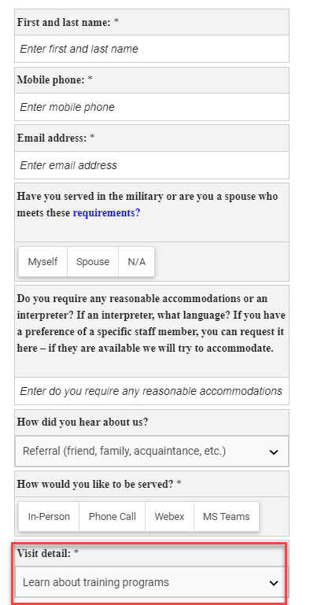
- Service Grouping and Visit details
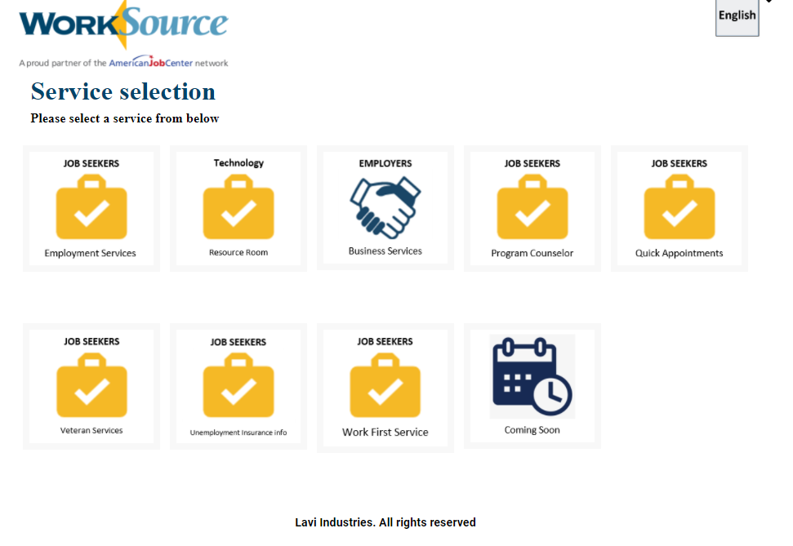
Figure 1- Service selection (Service Grouping)

Figure 2 - Visit detail is a list of services that fall within the service grouping chosen

Explanation: A service grouping is the main category of the service you want offered in your office. Each Service Grouping can have its own appointment calendar, hours of operations, and custom messaging. The Visit Details are the services provided under each grouping.
Instructions: Indicate which Service Grouping you want for your office. For each Service Grouping, indicate what visit details will fall under those grouping.
Note: Please do not change the Service Grouping name of the existing set. If you don’t need or offer a service grouping, please uncheck/indicate No as needed. You can add/remove existing service grouping visit details. If you have additional Service Grouping you need for your office, add new rows and its applicable service details. If you will be scheduling services for these categories, please mark “Y.” You will have an opportunity later in the document to make any of these groupings invisible to customers.

Needed? Y/N | Service Grouping Name | Service Grouping visit details
 | Business Services (for employers) | - Receive orientation to WorkSource (recommended for first time customers)  - Complete job listings  - Receive a general consultation  - Conduct labor market analysis
 | Computer and equipment use | - Access computer or wi-fi (in-person only)  - Print and fax documents (in-person only)
 | Education and training opportunities | - Connect with training opportunities  - Receive information about in-demand industry sectors and occupations
 | Connect to unemployment insurance information | - Connect to unemployment insurance information
 | Help finding a job | - Receive orientation to WorkSource (recommended for first time customers)  - Complete resume or application  - Identify your skills and abilities  - Learn how to interview and network  - General job search and placement assistance  - Receive assistance to register in worksourcewa.com
 | Check in with program counselor | - Check in with program counselor
 | Quick Appointments
 | Other | - Link to community resources  - Receive information about the WorkSource system, including performance and cost information
 | <add Service Grouping as needed> | <add service details as needed>

- Service durations
Explanation: The service duration is the length of an appointment. How long should the appointment be for each service?
Instructions: Provide the name of the Service Grouping and the duration for the appointment (Pro tip: copy and paste service groupings from above). Note: each service category can have a different duration.
Service Grouping Name | Appointment duration (in minutes)
Business Services (for employers) | Example: 60 minutes
Computer and equipment use
Education and training opportunities
Connect to unemployment insurance information
Help finding a job
Check in with program counselor
Quick Appointments
Other
<add Service Grouping as needed>

- Max Days
Explanation: How many days in advance can a customer schedule an appointment in your office?
Instructions: Provide the name of the Service Grouping (Pro tip: copy and paste service groupings from above). Tell us how many days in advance a customer can make an appointment.

Service Grouping Name | Max days
Business Services (for employers) | Example: 7days
Computer and equipment use
Education and training opportunities
Connect to unemployment insurance information
Help finding a job
Check in with program counselor
Quick Appointments
Other
<add Service Grouping as needed>

- Office Schedule
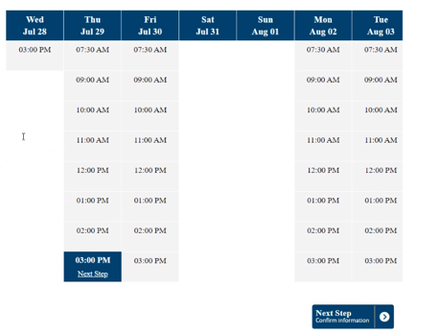
Figure 1 - Example schedule
Explanation: What does your ideal appointment schedule look like? Each Service Grouping can have its own hours of operations. For example, maybe an office does not want appointments during the 12-1pm lunch time, or no appointments on Fridays.
Instructions: Complete the table below, adding in the timeslots you want each Service Grouping to operate (first appointment and last appointment) for each day of the week. Note: You may set as many or as few appointments as you wish.
Service Grouping Name | Sunday | Monday | Tuesday | Wednesday | Thursday | Friday | Saturday
Example: Help Finding a job |  | 9-11a  1-4p | 9-11a  1-4p |  | 9-11a  1-4p
Business Services (for employers)
Computer and equipment use
Education and training opportunities
Connect to unemployment insurance information
Help finding a job
Check in with program counselor
Quick Appointments
Other
<add Service Grouping as needed>

- Number of Appointments
Explanation: How many appointments are available in my office per timeslot?
Instructions: Indicate how many appointments are available per timeslot for each service category. (Pro tip: copy and paste service categories from above)
Example: If you have 3 staff available to serve customers from 8-9, you could have three 8:00 – 9:00 appointments available until the time is unavailable.
Service Grouping Name | Number of Appointments per timeslot
Example: Help Finding a job | 3
Business Services (for employers)
Computer and equipment use
Education and training opportunities
Connect to unemployment insurance information
Help finding a job
Check in with program counselor
Quick Appointments
Other
<add Service Grouping as needed>

- Limited Time
Explanation: How soon from the current time (in minutes) that a same day appointment can be made?
Note/Example: Let’s say that you want to prevent customers from scheduling an appointment prior to 60 minutes of an available timeslot because you want to allow staff time to prepare. This means that at 3:01, an appointment cannot be made for 4:00 because it’s not 60 minutes prior to an appointment. The 3:00 timeslot will not be available. You can set this time to whatever works best for your office (0 min, 15 min, 30 min, 60 min…..).
Instructions: Indicate how many minutes BEFORE an available timeslot that an appointment can be made. This is configured per service category. (Pro tip: copy and paste service categories from above)
Service Grouping Name | Limited Time – how soon can an appointment be made?
Example: Help Finding a job | 60 minutes
Business Services (for employers)
Computer and equipment use
Education and training opportunities
Connect to unemployment insurance information
Help finding a job
Check in with program counselor
Quick Appointments
Other
<add Service Grouping as needed>

- Visible to customer?
Explanation: Do you want your service categories visible to customers so that they can self-schedule appointments? For example, do you want customers to go to https://worksourcewa.com and be able to self-book appointments and if so, which Service Groupings do you want to allow them to self-book? Note: Allowing customers to self-book appointments will give flexibility to customers, and free up staff from having to book appointments for customers.
Instructions: Indicate what services (if any) that you want to be visible to the customer for self-scheduling. (Pro tip: copy and paste service categories from above)

Service Grouping Name | Visible to customer?
Example: Help Finding a job | NO
Business Services (for employers)
Computer and equipment use
Education and training opportunities
Connect to unemployment insurance information
Help finding a job
Check in with program counselor
Quick Appointments
Other
<add Service Grouping as needed>

- How soon can a customer check in?
Explanation: This is a global setting that applies to your Queue Management Dashboard for every user and every service. You can decide what works for your office.
Instructions: Enter the amount of time (in minutes) that a customer can check in prior to an appointment. If the customer checks in before this time, they will receive a message stating similar “Please check in within x amount of minutes to your scheduled appointment”
Number of minutes PRIOR to an appointment that a customer can check in
Example: 10 Minutes

- How late can a customer check in?
Explanation: This is a global setting that applies to your Queue Management Dashboard for every user and every service. You can decide what works best for your office.
Do you want to allow customers to check in late? If so, how late?
Instructions: Enter the amount of time (in minutes) that a late customer can check in. Note: You do not have to place a limit on late check in – you may choose to not have a limit if it makes sense for your office.
Number of minutes AFTER an appointment that a customer can check in
Example: 10 Minutes

- For in-person Walk-in customers – do you want to allow in-person walk-in customers?
Explanation: Qtrac has the ability to handle in-person, same day walk-in customers to your office. Qtrac provides the ability for customers to register themselves as in-person walk-ins, and for staff assisted walk-in customers.
Instructions: Indicate if you plan on using Qtrac to manage in-person walk-in customers?

Do you want to use Qtrac to manage in-person walk-in customer? YES or NO?

- For in-person Walk-in customers – hours allowed for walk-in customers
Explanation: Qtrac has the ability to handle in-person, same day walk-in customers to your office. Qtrac provides the ability for customers to register themselves as in-person walk-ins, and for staff assisted walk-in customers. You can decide the hours you would open walk-in customers to your office and when you would have staff available to handle walk-in customers.
Instructions: Complete the table below, adding in the timeslots you want to allow walk-in customers at your office, and what are the days you don’t want to allow walk-in customers

Sunday | Monday | Tuesday | Wednesday | Thursday | Friday | Saturday
Example: | 9-10a  1-3p | 9-10a  1-3p | 9-10a  1-3p | 9-10a  1-3p | 9-10a  1-3p

- For in-person Walk-in customers – walk-in capacity?
Explanation: Qtrac has the ability to handle in-person, same day walk-in customers to your office. Qtrac provides the ability for customers to register themselves as in-person walk-ins, and for staff assisted walk-in customers. Your office can specify the capacity of the walk-in queue length/line. For example, you only want 10 walk-in customers at a specific point in time
Instructions: Indicate below the max walk-in queue length/line, and the message they will receive if walk-in queue length is at capacity.
What is the maximum walk-in queue length?
Example: 10 walk-ins at a time

What is the message you want sent if your office has reached maximum number of walk-in customers?
Example: We’re sorry, but we are at capacity. Please visit worksourcewa.com to make an appointment.

