For WorkSource staff on non-ESD equipment:
How to login to the Qtrac staff management portal

For WorkSource staff on Non-ESD equipment will be required to use Secure Access Washington to authenticate and login to the Qtrac Staff Management portal.
- Go to https://wpc.wa.gov and navigate to Technology tab, then select Log-on under ‘Qtrac Scheduling’ on the left hand navigation bar.
  - You can also bookmark this link in your primary internet browser for directly access to the staff login: https://ead.sts.wa.gov/adfs/ls/idpinitiatedsignon.aspx?LoginToRp=https://worksourcewa.lavi.com/mgmt/saml/metadata

- You will be presented with this window:
- For non-ESD WorkSource staff - Select ‘Secure Access Washington’

- You will then be redirected to the Secure Access Washington login page

- Login with your SAW username and password, or sign up for your SAW account

- After entering your SAW account logins, you will be redirected to the Qtrac Staff Management portal

Staff will see the below screen:
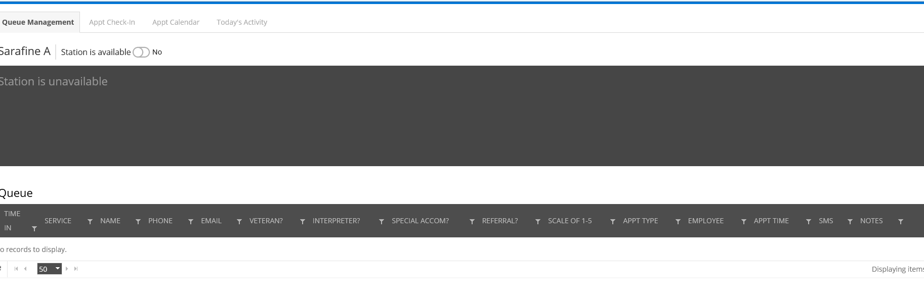
Super users will see the below screen:
