For WorkSource Staff on ESD equipment:
How to login to the Qtrac staff management portal with Single Sign On

Staff using ESD equipment will be using Single Sign On to access the Qtrac Staff Management Portal

- Go to https://wpc.wa.gov and navigate to Technology tab, then select Log-on under ‘Qtrac Scheduling’ on the left hand navigation bar.
  - You can also bookmark this link in your primary internet browser for directly access to the staff login: https://ead.sts.wa.gov/adfs/ls/idpinitiatedsignon.aspx?LoginToRp=https://worksourcewa.lavi.com/mgmt/saml/metadata

- You will be presented with this window:
- For ESD WorkSource staff - Select 'Active Directory’

- You will then automatically be logged in with your Active Directory credentials, and redirected to Qtrac Staff Management portal

Staff will see the below screen:

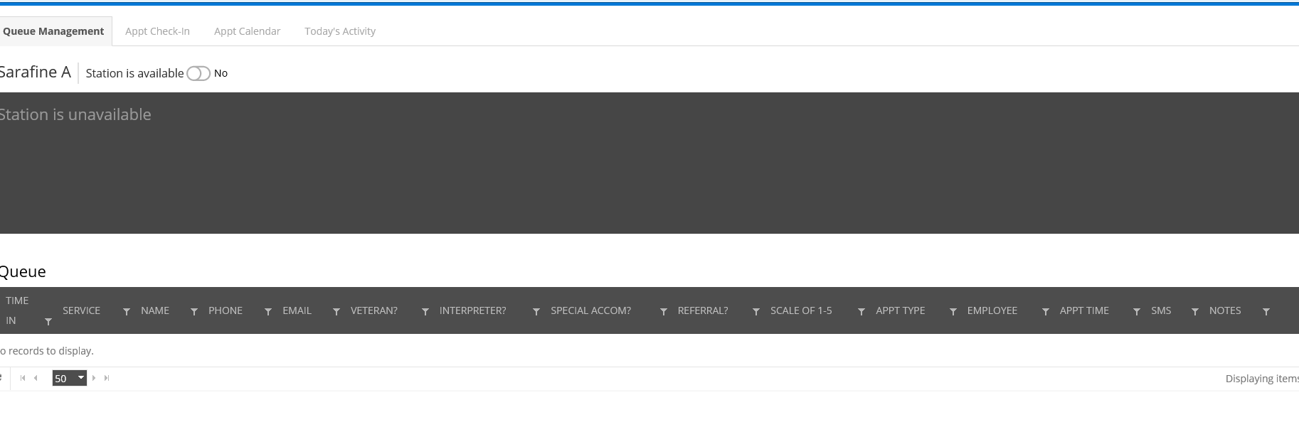
Super users will see the below screen:
