T12 Meeting Minutes 12-2-2020
Remember: After starting a Webex meeting to mute your audio and disable the video feature. Too many attendee’s with active video can interfere with everyone’s audio quality. Hover over the lower edge of your monitor screen to find the icons.

Thanks to all who contribute to this weekly call!

New Business

- 12/9/20 T12 meeting cancelled. See you on 12/16/20
- ETO Enhancements updates -
  - Create an ETO Participant record by staff so you can record services – on hold, implementation date TBD
- Tickets into production – nothing this week
- ETO/WSWA maintenance – ETO unavailable from Saturday from 6PM PT – Sunday at 3AM PT
- Velaro maintenance – maintenance activity on Friday, December 4, at 3:30:00 AM PT, the estimated duration is 1 hour. We do not expect any impact to your service, yet in some cases, there may be a brief interruption.
Training issue(s) of the week –
  - Reminder: Submit remedy tickets for all work requests. My team cannot begin work without a service request. Reaching out to us directly can affect the time it takes to resolve your issue. Thanks!
- ETO Engage Survey – We began work on training material plan and are getting closer to training!
- What’s new on WPC – Almost there, nothing this week but am in the process of revamping the look and will post material next week.
- ETO Basic and Refresher Training
  - ETO Basic training is the 1st Monday 10-12 and 3rd Tuesday 2-4 of every month (except holidays). Send email to Lynn Aue to receive more information, training account if needed and be added to the training Webex call. Invites should not be forwarded.
  - Training recordings and user guides are posted on the WPC website here https://wpc.wa.gov/tech/ETO-refresher-training
  - Submit a remedy ticket requesting additional training opportunities and resources
- Open discussion –
  - Training accounts vs test participants. Training accounts are in the training environment and are used for training staff who don’t have access to ETO. The training environment is a mirror of the live (production) environment. There are “Test” participant accounts for use by all staff. Type Test or Fake into the quick search bar and select WorkSource as the office to find a test participant account.
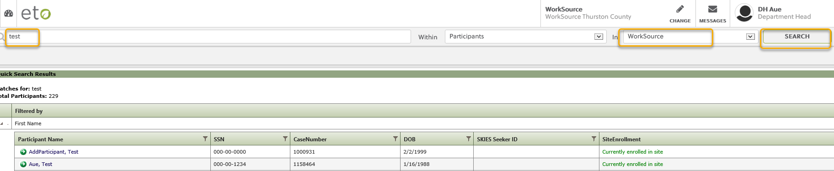

- UI announcements –
  - Optional job search extended through 12/07/20
  - Job search information found here https://esd.wa.gov/unemployment/job-search-requirements
  - Here is the information to provide feedback on Work Search Requirements
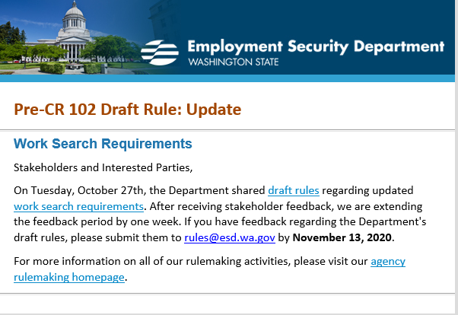

During the week of November 15-21, there were 30,274 initial regular unemployment claims (up79.8% from the prior week) and 464,884 total claims for all unemployment benefit categories (up 7.1% from the prior week) filed by Washingtonians, according to the Employment Security Department (ESD).
  - Initial regular claims applications remain at elevated levels and are at 263 percent above last year’s weekly new claims applications.
  - Pandemic Unemployment Assistance (PUA) and Pandemic Emergency Unemployment Compensation initial claims decreased over the week.
  - Continued/ongoing claims for regular benefits increased 3.5 percent over the week.
  - The increase in initial claims over the week was seen across the nation. Initial claims figures include both new and restarted claims by previous customers.
  - In Washington:
    - Increases occurred predominately in the Accommodation and Food Services sector (+6,937 initial claims).
    - Increases also occurred in the Arts, Entertainment and Recreation sector (+986 initial claims) and Retail trade sector (+779 initial claims).
    - The largest increase by occupation occurred in food preparation and serving (+7,954 over the week). This is likely attributed to the COVID-19 public health restrictions recently put in place.
In the week ending November 21, ESD paid out over $135.5 million for 282,837 individual claims. Since the crisis began in March, ESD has paid more than $12.5 billion in benefits to over a million Washingtonians.
- ESD.wa.gov or ESD Facebook page for current UI information
- Before submitting a service ticket help
Review of ETO/WSWA and other resources (AKA old business)
- Encourage all staff who use ETO and WSWA to sign up for the T12 calls. These calls are not just for trainers but for all system users and a great way to stay up to date on changes or improvements to ETO and WSWA. Send requests to esdgpWSSteam@esd.wa.gov to be added to the ITSD Training Team’s distribution list
- WorkSource Systems resources found on the WPC Technology site https://wpc.wa.gov/tech
  - We try our best to make sure all the links are operational but depend on you to submit a remedy ticket if you find broken links!
- WSWA Virtual services to assist job seekers/employers to sharpen skills. There are many tools on WSWA but here are a couple of my favorites!
Check out these virtual classes under Resources>Training and other programs.

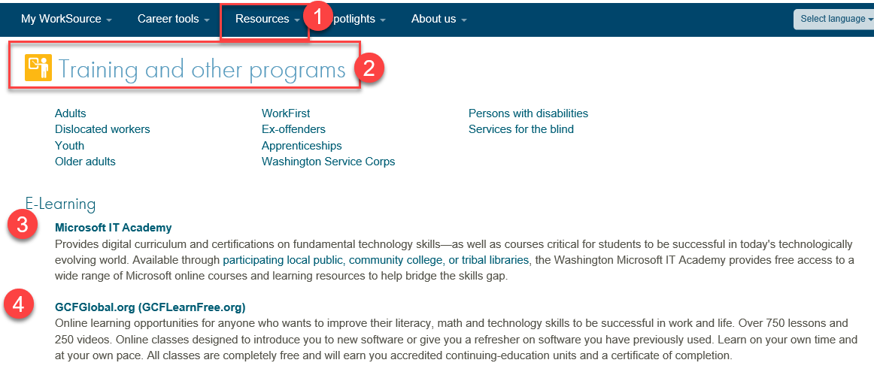

- Stay up to date on COVID19, teleworking and WorkSource Virtual services. Check out the information the WPC website to help all WorkSource staff telework.
  - IT service delivery
  - WebEx
    - Browse the Webex handbook and watch 5 videos on how to make the most out of this tool for conducting meetings with staff and customers.
  - Other resources include:
    - Now that you are teleworking reference guide
    - How to use SKYPE for online meetings
    - How to sign into ESD email from outside the network
    - How to sign into an off-site Wi-Fi from your computer
    - Can I access Internet Explorer from a MAC computer?
    - ESD service Desk information.
- UI Fraud help
  - www.esd.wa.gov/fraud
  - Fax information to claims centers 833-572-8423 –calling is not recommended due to the high volume of calls
  - Reviewing our web resources with them. Some helpful pages include:
- Employee FAQs
- Employee instructional videos
- How to file weekly claims
But you CAN’T help by:
  - Contacting an intake agent at the claims center and asking them to review your friend or family member’s claim or solve their issue.
  - Using your influence to move your friend or family member’s claim up the queue to be processed faster.
  - Using your influence to give any kind of advantage to your friend or family member.
  - Using your access to UTAB, if you have it, to give someone information about their claim.
  - Using your friend or family member’s SAW account and applying for benefits or submitting their weekly claims for them.
- Cisco Softphones training material Link http://insideesd.wa.gov/services/it-services
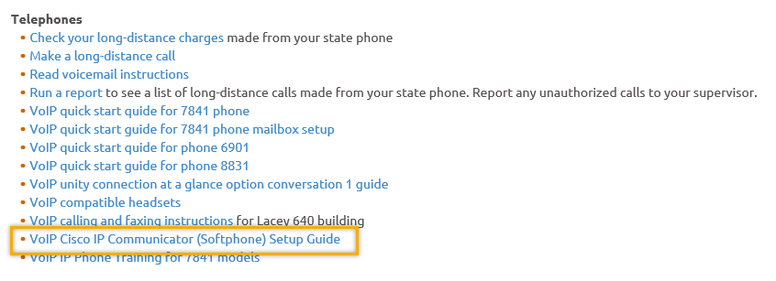
- Before submitting a service, request review these suggestions as the services desk will ask you to run through these steps. Many times, this resolves your issue without a service request!

  - Remember to log out of ETO, clicking off the browser tab here does not end your ETO session and will create issues when you log in again.
      - Always logout by opening your profile menu and clicking “Logout”
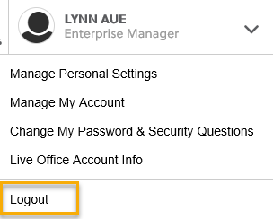
  - If you were impersonating a seeker or recruiter from ETO to WSWA remember to end the session, found in the upper left-hand corner. Clicking off your internet browser tab does not end impersonation!
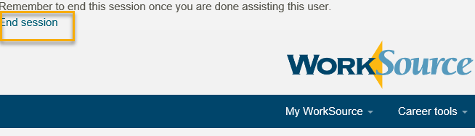

- For best performance clear your cache weekly

  - Internet Explorer (IE): Clearing IE cache starts from the top right side of the browser bar, click the settings icon and select Internet Options
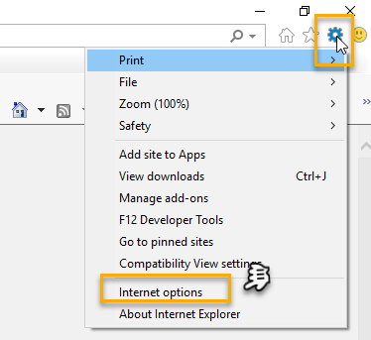

    - From the “General” tab click “Delete” which takes you to the “Delete Browsing History” screen. If not already checked click on the 2 boxes outlined here and click “Delete” you will return to the “General” tab

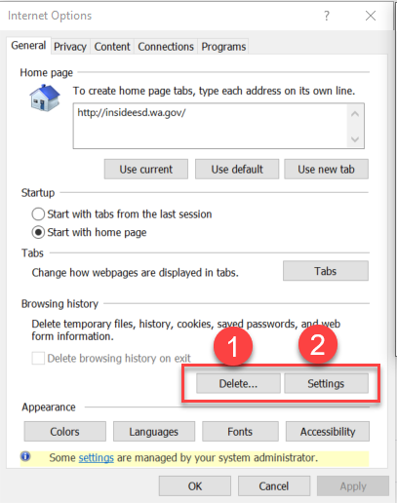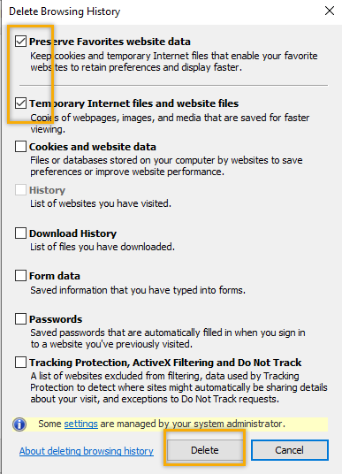

    - Next click “Settings” and if not selected click the radio button for “Every time I visit the webpage” This ensures you are using the most up to date version of ETO. Click OK
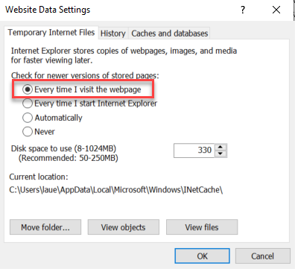
      - You will return to the General tab and click Apply and OK to complete the process of clearing your cache

  - Clearing Chrome cache starts from the top right side of the browser bar
- Click the triple dots to open the Chrome tools menu
- Hover over “More tools”
- Click “Clear browsing data” which opens a new screen
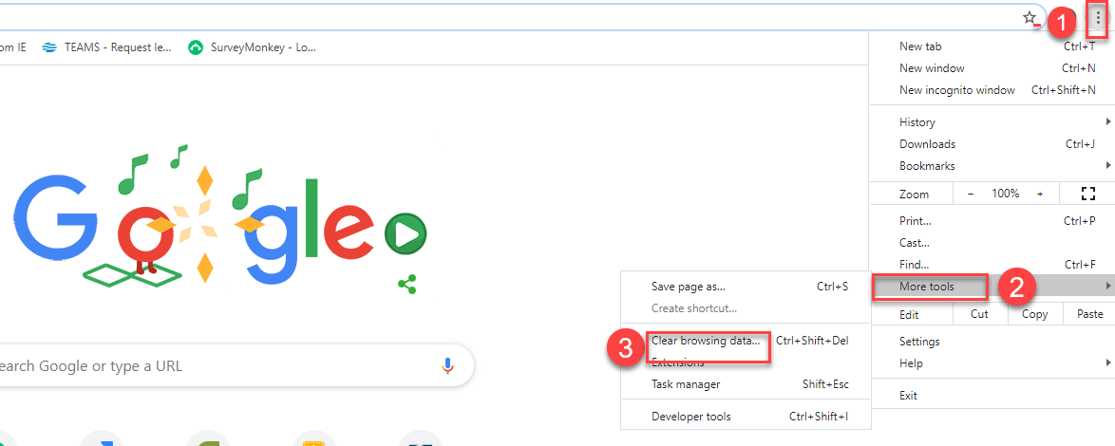

- Click “Clear data”
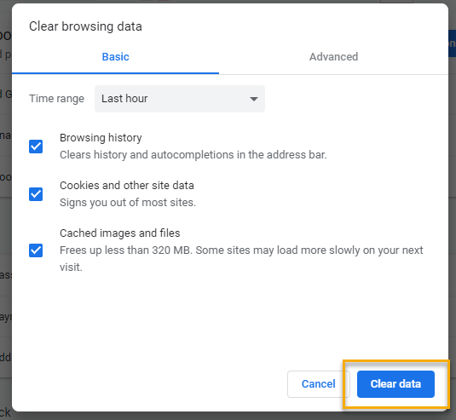

  - Finish by restarting your computer
  - If you still experience issues submit a service request https://wpc.wa.gov/tech/issues
CHAT

Nothing this week

ATTENDEES
Aaron Parrott
Abby Taft
Adeline Kerns
Adelp
A Johnson
Ariana
Boliveri
Brooklynn Zanto
C
Christina Shaffer
Dean Coxford
Donna Hendrickson
Dorothy Rocha
Douglas Evans
Eileen Boylston
Elijah Wabnitz
Elizabeth Ibanez
Emily Anderson
Gdram
Heidi Lamers
Irene Jordan
Ione Turner
Katherine Congleton
Kylie Bartlett
Lisa Pietkauskis
Luci Bench
Lux Dmitri
Maria Zaragoza
Melissa Maynard
Michael Ensor
Robin Gard
Sean McElligott
Selma Tekle
Skyler Blumenthal
Talia Ni Dufaigh
Tamela McNamee
Teresa Anda
Teresa Sparks
Timothy Mallon
Toni Burrow
Tracy Ferrell
Vdamneun
Young Suh

Attended second half

