T12 Meeting Minutes 11-25-2020
Remember: After starting a Webex meeting to mute your audio and disable the video feature. Too many attendee’s with active video can interfere with everyone’s audio quality. Hover over the lower edge of your monitor screen to find the icons.

Thanks to all who contribute to this weekly call!

New Business
- ETO Enhancements updates -
  - Create an ETO Participant record by staff so you can record services – on hold, implementation date TBD
- Tickets into production – nothing this week
- ETO/WSWA maintenance – nothing this week
- Velaro maintenance – nothing this week
- Training issue(s) of the week –
  - Program Enrollments: System exits See open discussion for more on this
  - Reminder: Submit remedy tickets for all work requests. My team cannot begin work without a service request. Reaching out to us directly can affect the time it takes to resolve your issue. Thanks!
- ETO Engage Survey – We began work on training material plan and are getting closer to training!
- What’s new on WPC – Almost there, nothing this week but am in the process of revamping the look and will post material next week.
- ETO Basic and Refresher Training
  - ETO Basic training is the 1st Monday 10-12 and 3rd Tuesday 2-4 of every month (except holidays). Send email to Lynn Aue to receive more information, training account if needed and be added to the training Webex call. Invites should not be forwarded.
  - Training recordings and user guides are posted on the WPC website here https://wpc.wa.gov/tech/ETO-refresher-training
  - Submit a remedy ticket requesting additional training opportunities and resources
- Open discussion –
  - System Exits (Programs)
    - ETO will program exit participants who have not had a qualifying service in 90 day. The Exit TP will record the actual exit date but the date of exit in the Program Enrollment TP will be the date the last qualifying service was entered. Here is an example:
      - Exit TP displays the system exit date of 11/18/20
      - Program Enrollment will display end date 8/18/20; 90 days prior to the system exit and the date of the qualifying service, not the date service was entered
      - Always open the Service TP associated with the system exited PE to verify that there was not a qualifying service provided (not date entered) within 90 days
      - If you have questions or need additional training on this submit a remedy ticket.
  - Orphaned services are services where the attached program was deleted. To correct this, you need to:
    - Open the service, review the PE name, date, etc
    - Record a new PE using the original PE name, date, etc
    - Record the service using the information in the orphaned service and attach it to the newly created PE
    - Delete the orphaned service
    - If you have questions or need additional training on this submit a remedy ticket.
- WSWA Virtual services to assist job seekers/employers to sharpen skills. There are many tools on WSWA but here are a couple of my favorites!
  - Check out these virtual classes under Resources>Training and other programs.
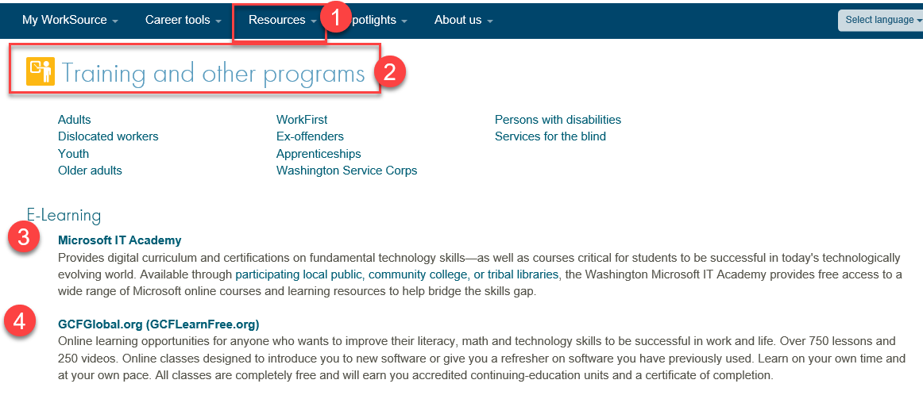
- UI announcements –
  - Optional job search extended through 12/07/20
  - Job search information found here https://esd.wa.gov/unemployment/job-search-requirements
  - Here is the information to provide feedback on Work Search Requirements
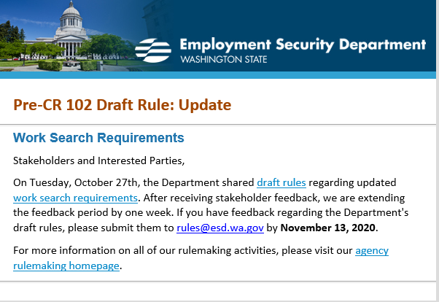

During the week of November 8-14, there were 14,837 initial regular unemployment claims (down 33.2% from the prior week) and 434,114 total claims for all unemployment benefit categories (up 1.2% from the prior week) filed by Washingtonians, according to the Employment Security Department (ESD).
  - Initial regular claims applications remain at elevated levels and are at 123 percent above last year’s weekly new claims applications.
  - Pandemic Unemployment Assistance (PUA) and Pandemic Emergency Unemployment Compensation initial claims decreased over the week.
  - Continued/ongoing claims for regular benefits increased 3.7 percent over the week.
  - The decrease in initial claims this week was expected. It is connected to a process required by law where some existing claimants must submit a new initial claim to ensure they are receiving benefits from the correct program. This process was a contributing factor to the increase in initial claims in last week’s release. You can learn more about that requirement on our website.
In the week ending November 14, ESD paid out over $128.2 million for 275,893 individual claims. Since the crisis began in March, ESD has paid more than $12.4 billion in benefits to over a million Washingtonians.
- ESD.wa.gov or ESD Facebook page for current UI information
- Before submitting a service ticket help
Review of ETO/WSWA and other resources (AKA old business)
- Encourage all staff who use ETO and WSWA to sign up for the T12 calls. These calls are not just for trainers but for all system users and a great way to stay up to date on changes or improvements to ETO and WSWA. Send requests to esdgpWSSteam@esd.wa.gov to be added to the ITSD Training Team’s distribution list
- WorkSource Systems resources found on the WPC Technology site https://wpc.wa.gov/tech
  - We try our best to make sure all the links are operational but depend on you to submit a remedy ticket if you find broken links!
- Stay up to date on COVID19, teleworking and WorkSource Virtual services. Check out the information the WPC website to help all WorkSource staff telework.
  - IT service delivery
  - WebEx
    - Browse the Webex handbook and watch 5 videos on how to make the most out of this tool for conducting meetings with staff and customers.
  - Other resources include:
    - Now that you are teleworking reference guide
    - How to use SKYPE for online meetings
    - How to sign into ESD email from outside the network
    - How to sign into an off-site Wi-Fi from your computer
    - Can I access Internet Explorer from a MAC computer?
    - ESD service Desk information.
- UI Fraud help
  - www.esd.wa.gov/fraud
  - Fax information to claims centers 833-572-8423 –calling is not recommended due to the high volume of calls
  - Reviewing our web resources with them. Some helpful pages include:
- Employee FAQs
- Employee instructional videos
- How to file weekly claims
But you CAN’T help by:
  - Contacting an intake agent at the claims center and asking them to review your friend or family member’s claim or solve their issue.
  - Using your influence to move your friend or family member’s claim up the queue to be processed faster.
  - Using your influence to give any kind of advantage to your friend or family member.
  - Using your access to UTAB, if you have it, to give someone information about their claim.
  - Using your friend or family member’s SAW account and applying for benefits or submitting their weekly claims for them.
- Cisco Softphones training material Link http://insideesd.wa.gov/services/it-services
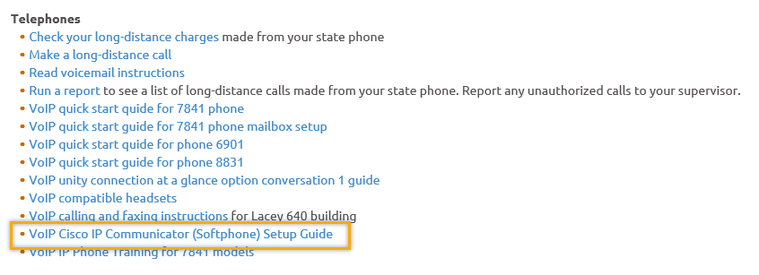
- Before submitting a service, request review these suggestions as the services desk will ask you to run through these steps. Many times, this resolves your issue without a service request!

  - Remember to log out of ETO, clicking off the browser tab here does not end your ETO session and will create issues when you log in again.
      - Always logout by opening your profile menu and clicking “Logout”
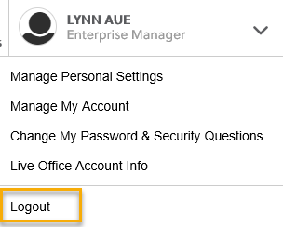
  - If you were impersonating a seeker or recruiter from ETO to WSWA remember to end the session, found in the upper left-hand corner. Clicking off your internet browser tab does not end impersonation!
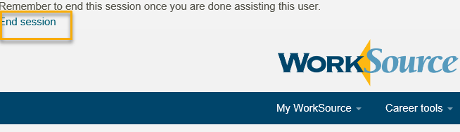

- For best performance clear your cache weekly

  - Internet Explorer (IE): Clearing IE cache starts from the top right side of the browser bar, click the settings icon and select Internet Options
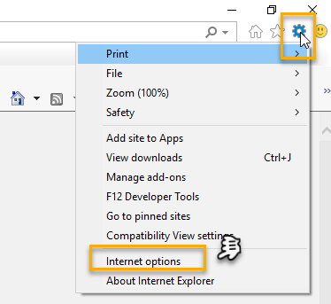

    - From the “General” tab click “Delete” which takes you to the “Delete Browsing History” screen. If not already checked click on the 2 boxes outlined here and click “Delete” you will return to the “General” tab

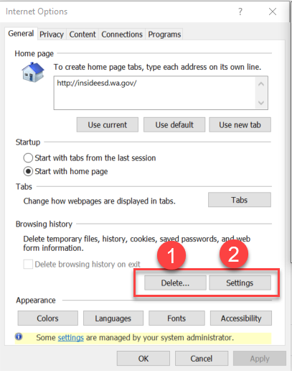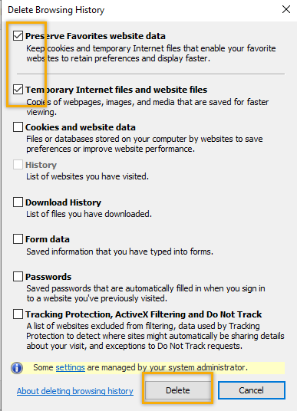

    - Next click “Settings” and if not selected click the radio button for “Every time I visit the webpage” This ensures you are using the most up to date version of ETO. Click OK
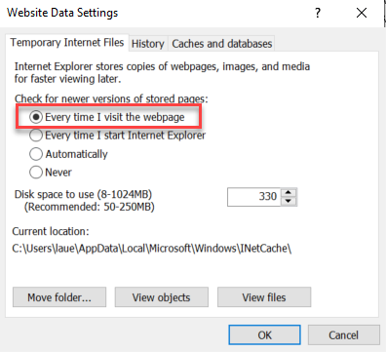
      - You will return to the General tab and click Apply and OK to complete the process of clearing your cache

  - Clearing Chrome cache starts from the top right side of the browser bar
- Click the triple dots to open the Chrome tools menu
- Hover over “More tools”
- Click “Clear browsing data” which opens a new screen
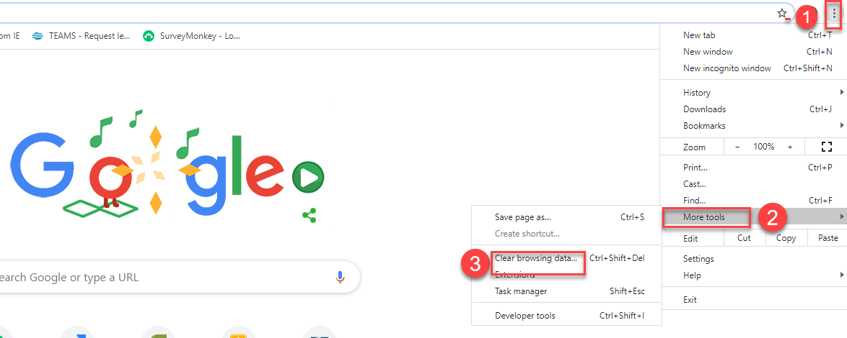

- Click “Clear data”
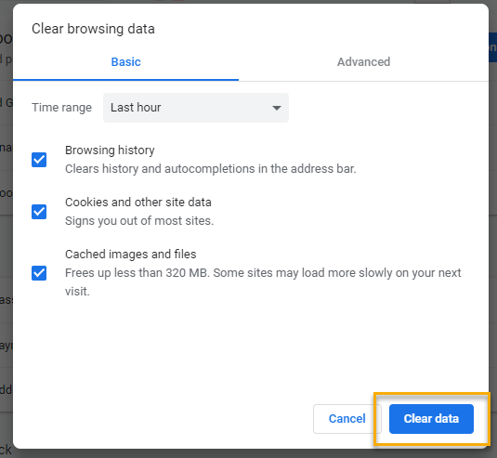

  - Finish by restarting your computer
  - If you still experience issues submit a service request https://wpc.wa.gov/tech/issues
CHAT
Regarding adding a participant record manually:
from Tamela McNamee to everyone: 10:13 AM
What is an orphaned touchpoint?
from Teresa Sparks to everyone: 10:14 AM
I have never heard of orphan services; can you enlighten me on this?

An Orphaned service/TP is when a parent program enrollment is opened, services are taken, and then that program enrollment is later deleted without having deleted the services within. Those touchpoints are ‘orphaned’ which cause issues with federal reporting. We will work on creating a desk aid to show how to clean these up.

from Skyler Blumenthal to everyone: 10:32 AM
WSS team e-mail: ESDGPWSSTeam@esd.wa.gov
Website for any issues (i.e. how to submit a remedy ticket): https://wpc.wa.gov/tech/issues

ATTENDEES

Attended second half

