How to log into Qtrac WorkSource Scheduler as a WorkSource staff
Qtrac is the WorkSource scheduling solution that customers and staff can use to book appointments at WorkSource offices for services.
The steps in this document details how WorkSource staff members (ESD and non-ESD WorkSource Staff) that have been granted access to use the Qtrac scheduling software will login to the Qtrac scheduling software to manage their customer engagements.

For ESD staff: How to login to the Qtrac staff management portal with Single Sign On
ESD staff will be using Single Sign On to access the Qtrac Staff Management Portal
- Go to https://wpc.wa.gov and navigate to Technology tab
  - 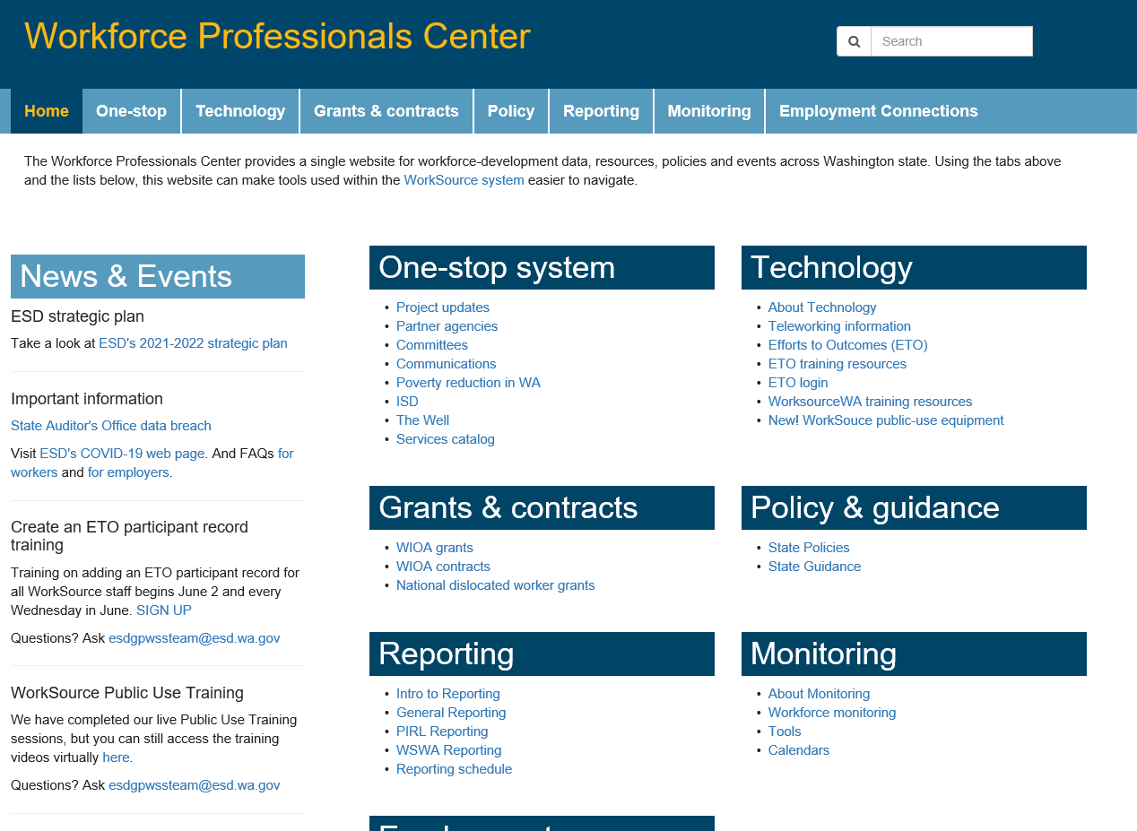
- Click on Qtrac Scheduling > Log-on link
  - You can also BOOKMARK this link in your primary internet browser to directly access the staff login https://ead.sts.wa.gov/adfs/ls/idpinitiatedsignon.aspx?LoginToRp=https://worksourcewa.lavi.com/mgmt/saml/metadata
- You will be presented with this window
- FOR ESD WorkSource Staff, select “ACTIVE DIRECTORY”
- You will then be logged in with your Active Directory credentials automatically, and redirected to Qtrac Staff Management portal
  - 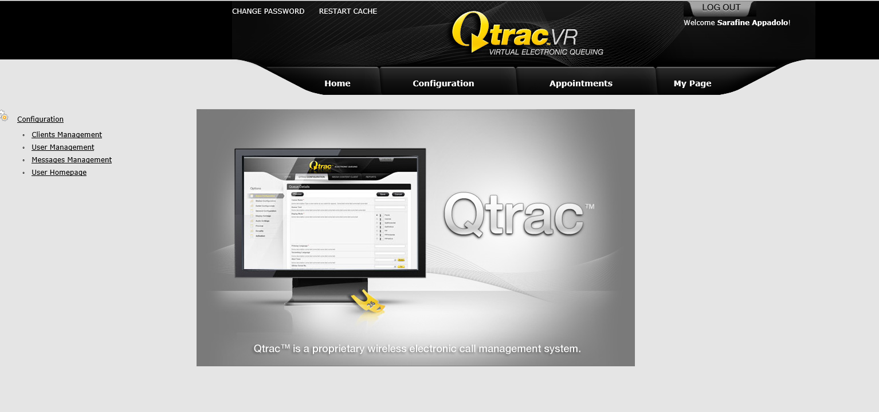
  - 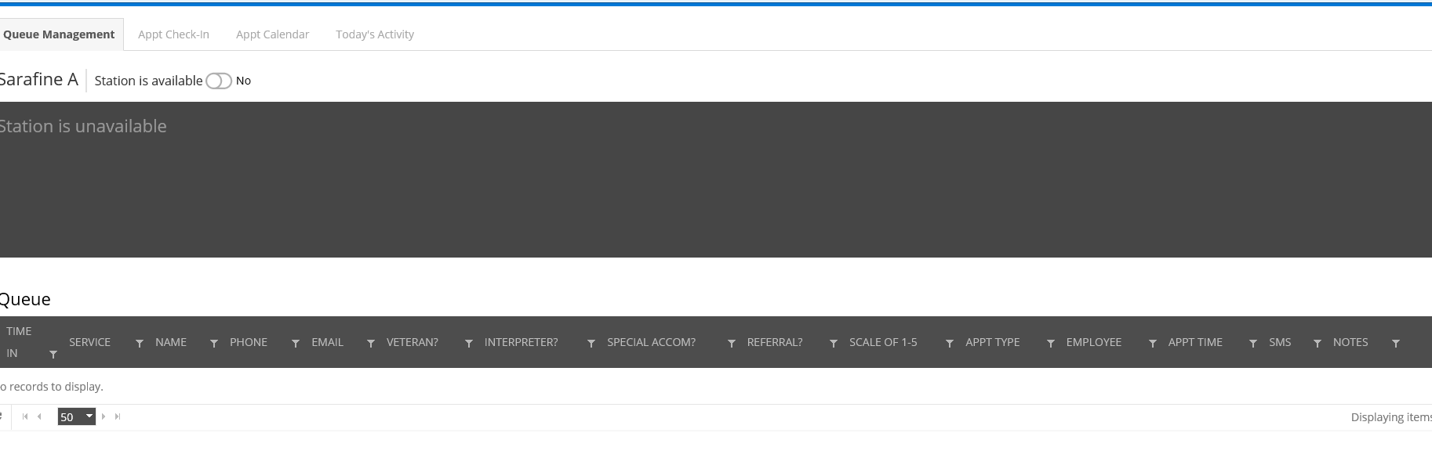
- You should now be in the Qtrac Staff Management Portal

For non-ESD staff: How to login to the Qtrac staff management portal
Non-ESD staff will be required to use Secure Access Washington to authenticate and login to the Qtrac Staff Management portal.
- Go to https://wpc.wa.gov and navigate to (INSERT WPC PAGE with LINK)
- Click on Qtrac Scheduling > Log-on link
  - You can also BOOKMARK this link in your primary internet browser to directly access the staff login https://ead.sts.wa.gov/adfs/ls/idpinitiatedsignon.aspx?LoginToRp=https://worksourcewa.lavi.com/mgmt/saml/metadata
- You will be presented with this window
- FOR non-ESD WorkSource Staff, select “Secure Access Washington”
- You will then be redirected to the Secure Access Washington login page.
- Login with your SAW user name and password, or sign up for your SAW account
- After entering your SAW account logins, you will be redirected to the Qtrac Staff Management portal

