Registered Apprenticeship

New Program Registration for

Sponsoring Organizations

Registered Apprenticeship

Registered Apprenticeship (RA) is a joint venture of an employer or group of employers and the Washington State Labor and Industries, Apprenticeship, that develops registered and credentialed apprenticeship programs available to qualified employers for career development of their industry’s workforce.

There are thousands of existing registered apprenticeship occupations. The easiest way for an employer to participate in registered apprenticeship is to be a training agent to an existing program that meets their business needs. If no program meet your needs or you are creating a new occupations, sponsoring a new program would be your other option.

EMPLOYER PARTICIPATION & REQUIREMENTS

Direct Business Involvement
Employers are the foundation of every apprenticeship program and the skills needed by their workforce are at the core. You will play an active role in building the program and be involved in every step of designing and implementing the apprenticeship program.

Related Supplemental Instruction (RSI)
Apprentices receive related instruction that complements on-the-job training (OJT). The instruction delivers the technical and academic competencies that apply to the job, and can be provided by a community college, a technical school, an apprenticeship training school — or by the business itself. It can be provided at the school, online, or at the job site.

Education partners often collaborate with business to develop the curriculum based on the skills and knowledge needed for the job.

On-the-Job Training (OJT)

Every program includes structured on-the-job training (OJT). Apprentices get hands on training from an experienced mentor at the job site for a minimum of one year. While employers provide the mentors and identify the skills and knowledge to be learned through OJT, partners can support the employer in developing the approach to OJT and identifying resources to support this component.

Rewards for Skill Gains

Apprentices receive an increase in pay as their skills and knowledge increase. Employers start by establishing an entry wage and an ending wage, and build in progressive wage increases throughout the apprenticeship as skill benchmarks are met by the apprentices. Progressive wage increases help reward and motivate apprentices as they advance through their training.

National Occupational Credential

Every graduate of a Registered Apprenticeship program receives a nationally-recognized credential upon demonstrated mastery of every skill and have all the knowledge needed to be fully proficient for the specific occupation.

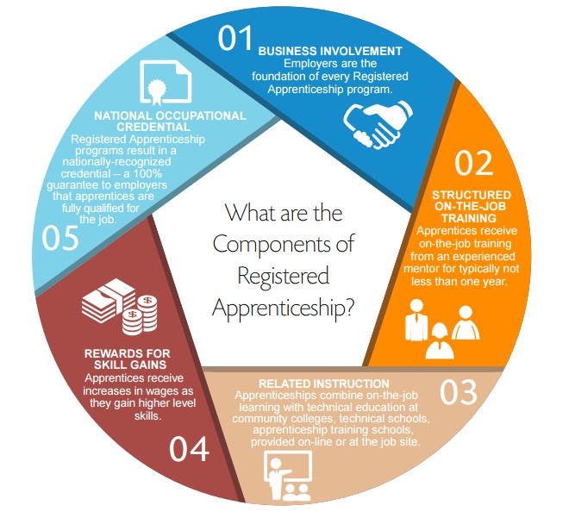
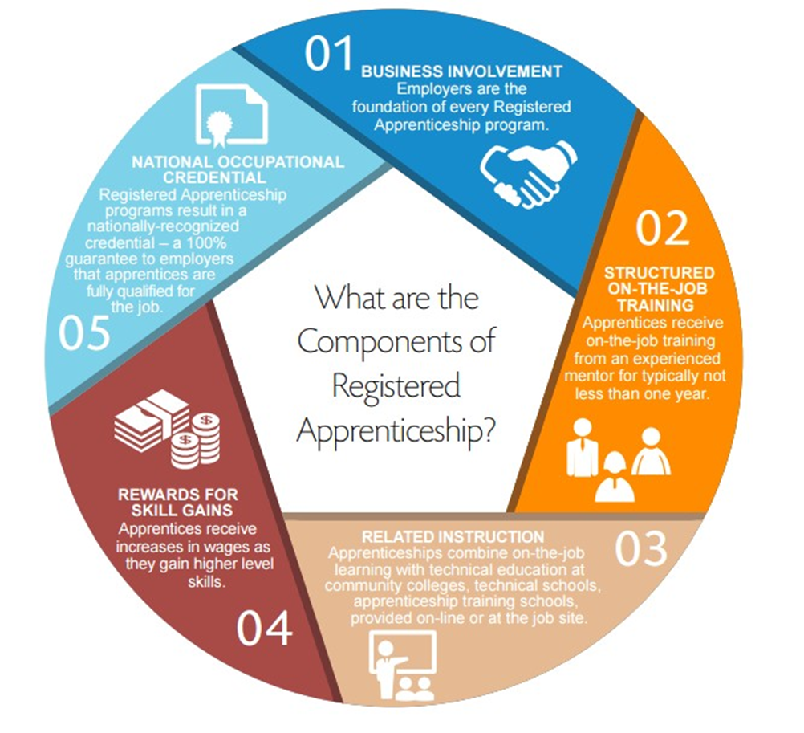

RESPONSIBILITIES OF A SPONSOR FOR A REGISTERED APPRENTICESHIP

There are many different models to structure a sponsoring organization. Some common sponsor partnership models are:
- Training Trust
- Intermediary
- Association

A single employer can also sponsor a registered apprenticeship. In each case, the activities performed by the sponsor to coordinate the RA program are the same.

Establish Apprenticeship Program

- Develop Program Standards
- Develop Related Supplemental Instruction (RSI)
- Establish journey level wage

Management of Apprenticeship Program

- Identify and register training agents
- Identify mentors
- Deliver on-the-job training (OJT)
- Monitor periodic wage progression
- Evaluate performance progress
- Report OJT & RSI hours to Labor and Industries

Monitoring Apprenticeship Program

- Apprentice selection and hiring processes
- Apprentice wage scale increase process
- Apprentice performance review process
- RSI delivery, education providers
- Training agents; mentoring and OJT delivery

Management of Apprentices

- Register apprentices with Labor & industries​
- Update status
- Administer discipline
- Monitor RSI and OJT hours​
- Provide wage scale increases based on RSI and OJT completion​
- Request/award certificates of completion to apprentice graduates​

“This workforce product was funded by a grant awarded by the U.S. Department of Labor’s Employment and Training Administration. The product was created by the recipient and does not necessarily reflect the official position of the U.S. Department of Labor. The Department of Labor makes no guarantees, warranties, or assurances of any kind, express or implied, with respect to such information, including any information on linked sites and including, but not limited to, accuracy of the information or its completeness, timeliness, usefulness, adequacy, continued availability, or ownership. This product is copyrighted by the institution that created it.”

