Employer Outreach for Apprenticeship-

A guide for business outreach personnel

Companies in all sectors of the American economy are facing complex workforce challenges in increasingly competitive domestic and global markets. Registered Apprenticeship is your proven solution for recruiting, training, and retaining world-class talent.

How to find employers

- Get referrals from agencies
- Review existing programs to determine what other employers are part of the same industry
- Discuss with employer organizations what use you can be to assist their members in understanding and potentially utilizing the apprenticeship system.
- Work with community colleges to help identify employers who are requesting training assistance
- The Centers of Excellence are resources to identify employers.
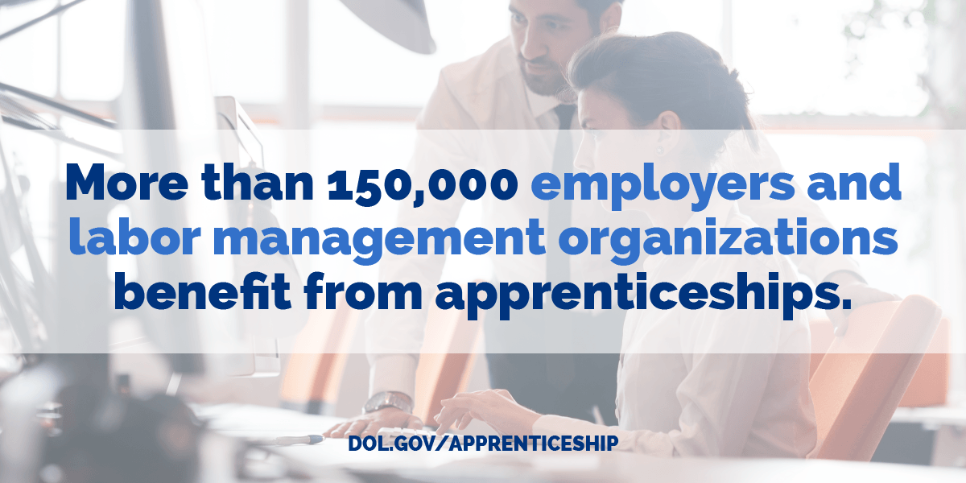
- Create web sites or other outreach efforts for employers to see so that they can contact you.
- Research employer organizations.

Research before reaching out
Know about the industry, sector or business before you reach out.
- What industry do they represent?
- How many employees do they have?
- Are they national or local?
- Do they have job descriptions?
- Do they have job openings or job recruitment?
- Do they appear to be expanding?
- Will you outreach to direct management or human resources?
- Do they have any existing connection with apprenticeship?
- What does the industry look like statewide?
- Have governmental agencies, such as Chamber of Commerce,
Done any workforce analysis?
- Have comparable companies have registered apprenticeship connections?

Initial Connection
It’s important to assess whether the employer/s have already been approached by other recruiters, navigators or consultants regarding initiating apprenticeship. We want to convey a consistent and collaborative approach. If they have, connect with them before meeting with employer.

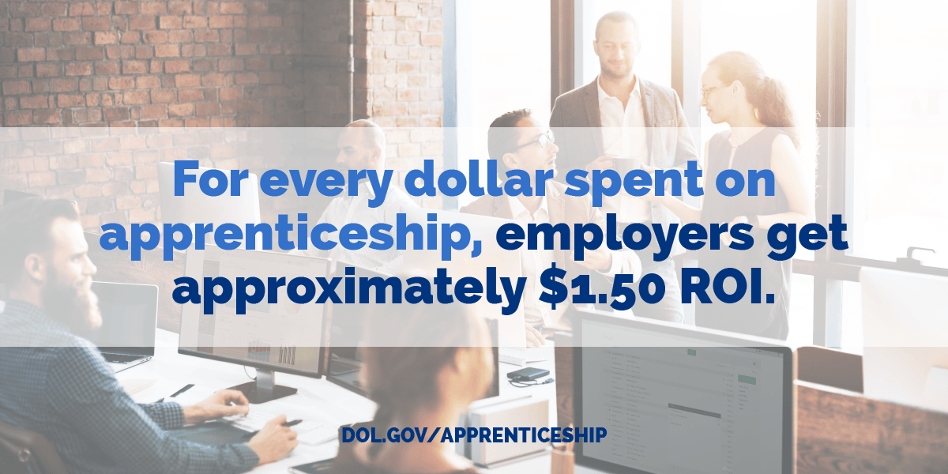

Don’t waste the employer’s time. Listen.
Demonstrate to the employer/s that you value their time by:
- ensuring that you are not repeating work done by another navigator or consultant.
- Have information in a packet that you can leave with the employer.
- Show up early.
- Listen more than talk. Write down what the employer has for questions and respond as soon as possible.

Accommodate the employer.
Meet them at their location at a time that it good for them. Show you value their time by being on time.
Your purpose is to provide guidance to employers to find workforce solutions. Understand the employer’s needs before steering them toward any solution. Ask questions like:
- How difficult is it to recruit workers that are skilled in the craft needed?
- How much turnover is occurring in the business?
- If employers claim to be trained, is the training a good fit for the employer?
- Is the employer losing contracts and potential profit because they do not have and cannot find adequately trained staff?
- Is subcontracting effective for getting the work done?

Apprenticeship is not the only workforce training tool, but if it is the best option for this employer, you’ll be there to guide them. Consider other options with them if they are interested.
Employers must feel that your interest is in what is best for their business.

Why apprenticeship?
What is the benefit to the employer?

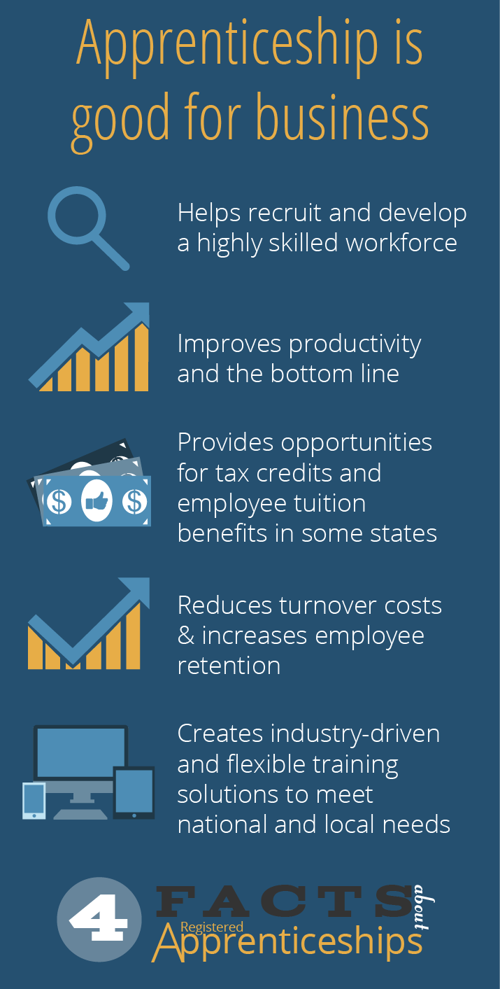

Share resources and benefits available to them through the registered apprenticeship system:
- Community and Technical Colleges with reduced curriculum costs for registered apprenticeship, assistance in developing curriculum, existing classes and partners, etc. By partnering with an accredited academic institution it creates a pathway for degree attainment, often with the addition of just four general education requirements
- Labor and Industries Consultant assistance. It would be useful to let LNI know early on what your outreach is doing.
- Work Force Development Councils, Economic Development Councils’ and grant recipients, can they be of help?
- Offering to identify existing curriculums regionally and federally.
- For union programs, connection with existing programs.

Potential Costs for Employers

- Related Supplemental Instruction
- Program Management Activities
- Mentoring oversight

How does apprenticeship work?
Once they’ve decided to explore apprenticeship, let them know there are two options:
- Joining an existing registered apprenticeship program as a training agent or
- Starting a new registered apprenticeship program as a sponsor

Have a listing of what those options might be such as connecting with employment security for assistance in gaining employees, internships etc.

Ask if they would like you to send them any information about apprenticeship:
- What is Apprenticeship (DOL information from AAI & RAISE grants).
- Whyapprenticeship.com is the Washington State website for apprenticeship expansion grant material and resource for information about apprenticeship. Look through the materials on the website. They are tools available to everyone.
- Don't send too much information by email. Listen to the employer and find information that would be helpful to them. Too much information can be overwhelming.
- Department of Labor Apprenticeship has great marketing and outreach materials available. Here is a link to an apprenticeship tutorial.

https://www.dol.gov/apprenticeship/toolkit/learn.htm

Connect them with partners

- Labor and Industries Apprenticeship Consultants http://www.lni.wa.gov/TradesLicensing/Apprenticeship/About/AppCoordinators/default.asp
- Community and Technical colleges https://www.sbctc.edu/
- Workforce Development Councils http://wtb.wa.gov/LocalWorkforcePlans.asp
- Economic Development Councils: https://www.eda.gov/resources/economic-development-directory/states/wa.htmWashington State Centers of Excellence www.coewa.com
- Other business partners that are in the apprenticeship system or are part of employer organizations.
- Discussion of State and Federal connections.
Follow-up
The apprenticeship system is complex and connection with it take time, energy and experience. Offer personal assistance to the employer. Referrals are a tool, but should not replace one-on-one service. Assure employers that you will check in with them at their convenience. Make sure they understand time frames for development like applying to Washington State Apprenticeship Training Council (WSATC),etc.

“This workforce product was funded by a grant awarded by the U.S. Department of Labor’s Employment and Training Administration. The product was created by the recipient and does not necessarily reflect the official position of the U.S. Department of Labor. The Department of Labor makes no guarantees, warranties, or assurances of any kind, express or implied, with respect to such information, including any information on linked sites and including, but not limited to, accuracy of the information or its completeness, timeliness, usefulness, adequacy, continued availability, or ownership. This product is copyrighted by the institution that created it.”

