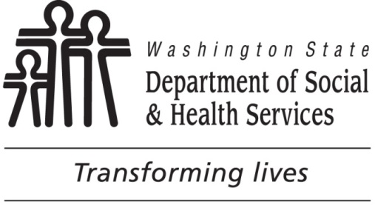

ROUGH DRAFT
March __, 2020

Governor Jay Inslee
Office of the Governor
PO Box 40002
Olympia, WA 98504-0002

Dear Governor Inslee,

We are writing on behalf of the Washington State Departments of Social and Health Services, Commerce, and Employment Security to enthusiastically express support for the Poverty Reduction Work Group’s 10-year Plan for the Future. We have had the privilege of being closely involved with the PRWG over the past two years to help develop a plan that, if implemented, will meaningfully and measurably reduce poverty and inequality in Washington State. Your support of poverty reduction has been and continues to be inspirational to all of us in state service. We look forward to partnering with you now to turn these plans into action.

Reducing poverty and inequity is critically important to the mission of the DSHS, Commerce and ESD. Our agencies are focused on serving the most vulnerable members of our communities, 1.8 million of whom are hurting from not being able to meet their daily needs. The success of the PRWG’s Plan will mean a decrease in hunger, unemployment, homelessness, and hopelessness for DSHS, Commerce and ESD clients. As the PRWG 10-year Plan states, we must “ensure social and economic opportunity and well-being exists for all Washingtonians, and that it be passed on from this generation to the next…and the next…and the next.”

We are very interested in the series of community engagement meetings that PRWG co-lead agencies will be conducting in order to finalize the 10-year Plan for the Future this summer. At DSHS, Commerce and ESD, we look forward to supporting their efforts by [Any specific actions we can note here, such as advertising the community meetings to DSHS, Commerce and ESD staff and on the DSHS, Commerce and ESD homepages; ensuring DSHS, Commerce and ESD staff attend the community meetings; listening to the community feedback to use in DSHS, Commerce and ESD’s current and future anti-poverty initiatives, etc?].

In the meantime, we urge your continued support of PRWG’s plan. Please take immediate steps to begin implementing it by:
- Directing state agencies to write action plans to fulfill the strategies outlined in the plan;
- Elevating the influence and expertise of people most affected by poverty in the implementation of the plan; and
- Funding the PRWG’s short-term priorities in the next budget cycle.

We pledge our fullest commitment to reaching the goals outlined in this powerful report, and asking leaders within our agencies to do the same. We have already heard from several that they hope to be proactively engaged in implementing activities in the 10-Year Plan. We believe the recommendations within this report will lay an equitable foundation in Washington State while also providing immediate, needed relief for Washingtonians currently struggling to make ends meet in communities throughout our state.

Thank you for planting the seeds of an equitably prosperous Washington state through the Poverty Reduction Work Group. DSHS, Commerce and ESD are committed to nurturing the growth of these seeds. If we can do anything further to support this effort, please do not hesitate to ask.

Sincerely,

Cheryl Strange, Secretary
Washington State Department of Social and Health Services
cheryl.strange@dshs.wa.gov

Lisa Brown, Director
Washington State Department of Commerce
lisa.brown@commerce.wa.gov

Suzi LeVine, Commissioner
Washington State Employment Security Department
slevine@esd.wa.gov

