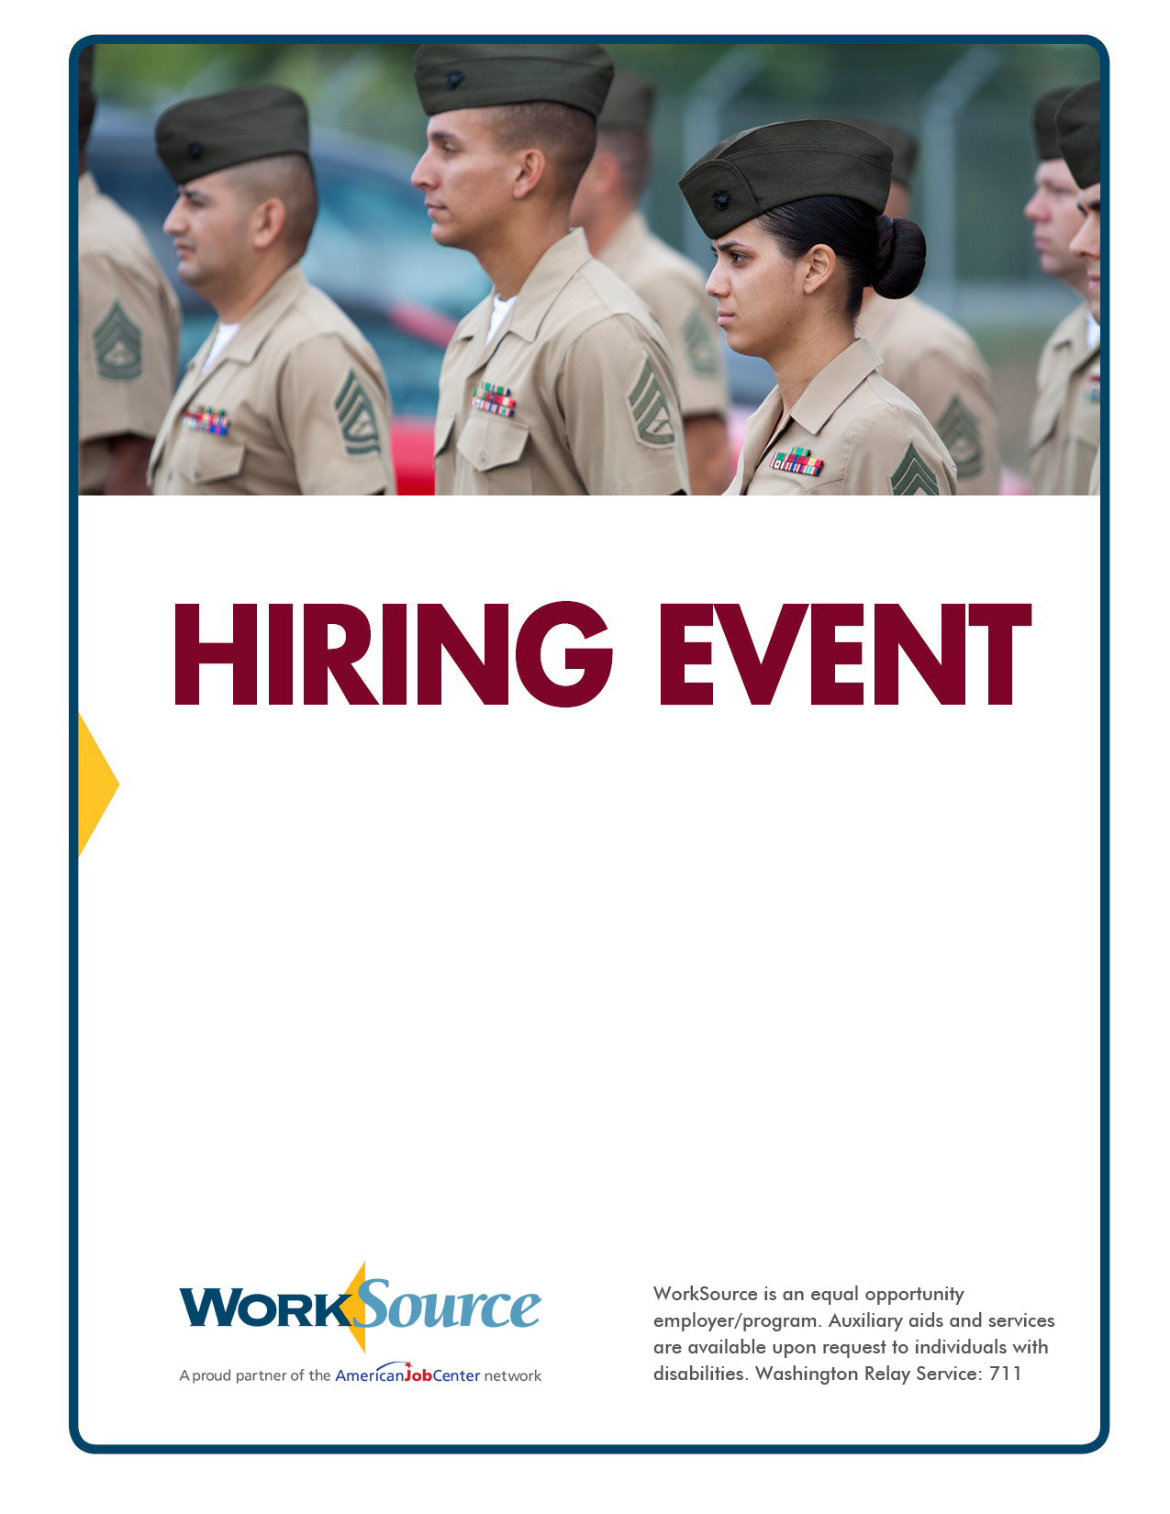

For more information, contact Kim Myers at 253-552-2547 or kmyers@esd.wa.gov

**Over 500 job openings   
in the following fields:**

**• Administration**

**• Medical**

**• Assembly   
• Warehousing**

**• Manufacturing**

**• Production**

**September 23**

**10 a.m. to 2 p.m.**

**LaQuinta Inn & Suites**

**11751 Pacific Highway SW, Lakewood**

**Pierce County Veteran Services**

**Admission is free!**

**This event is open to the public. Please bring your résumé and be prepared to interview for jobs.**