­­­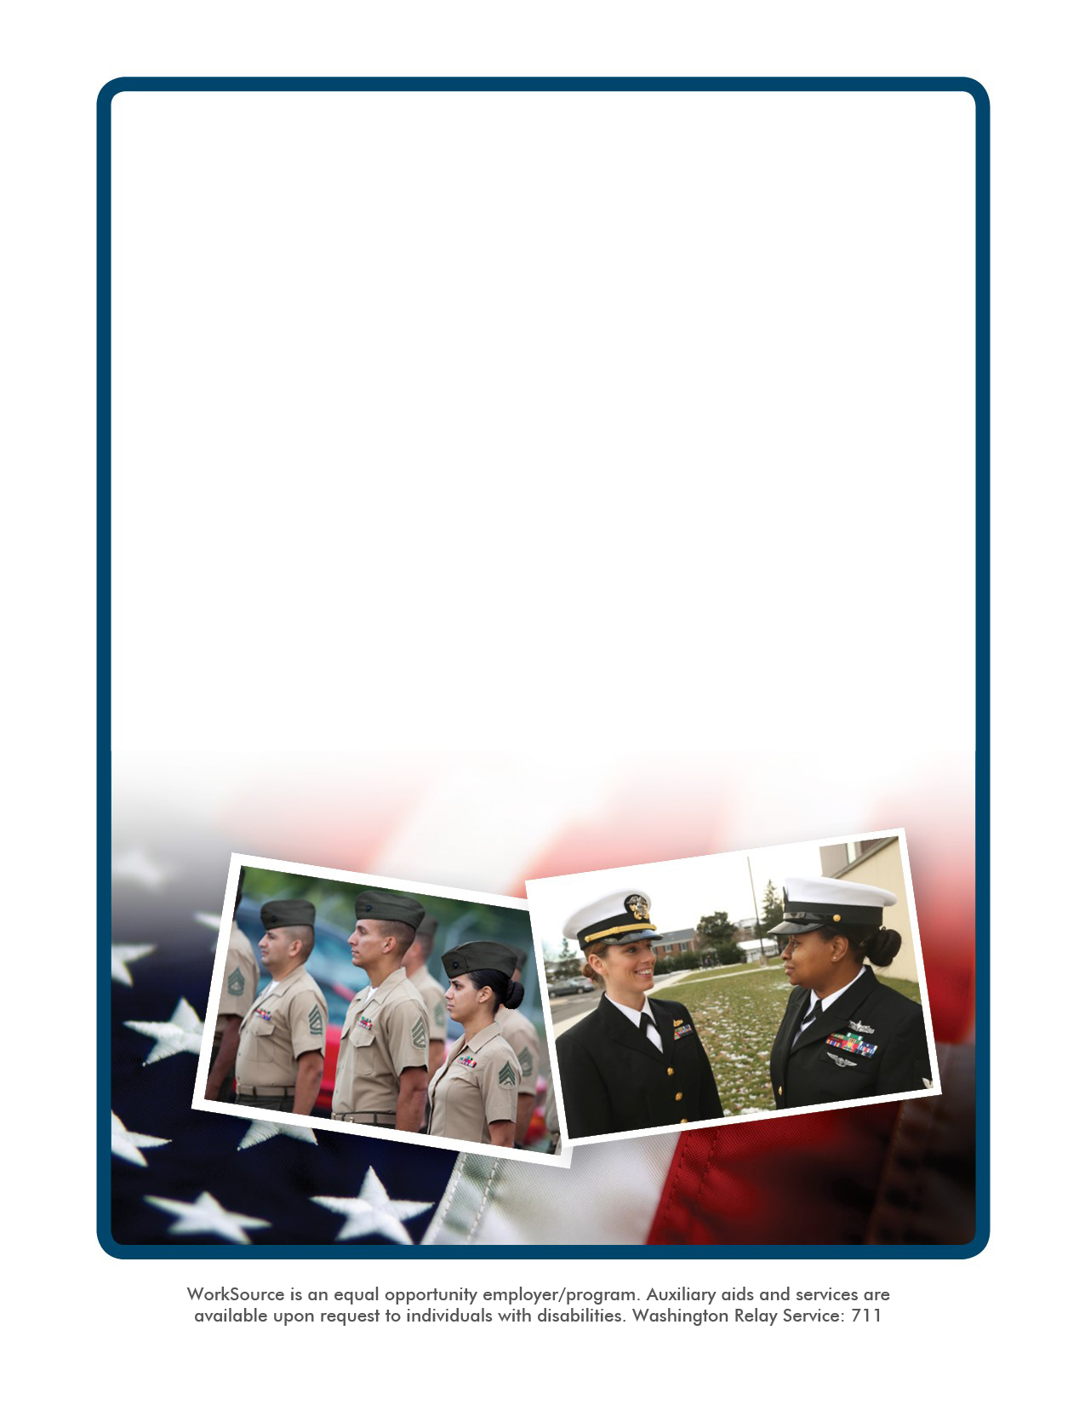

**Held in recognition and support of our southwest communities.**

**Healthcare • Transportation • Advanced Manufacturing**

**Construction • Law Enforcement • Retail Sales • Other**

**November 20, 12 a.m. to 3:30 p.m.**

**Over 70 businesses attending!**

All job seekers are welcome

* Dress professionally
* Be prepared to interview
* Bring your resume

**VETERANS JOB FAIR**

For more information, contact Kim Myers at 253-552-2547 or kmyers@esd.wa.gov

**Brought to you by WorkSource Thurston Veterans Unit**

**National Guard Armory**

**515 Eastside ST SE,**

**Olympia, WA 98501**