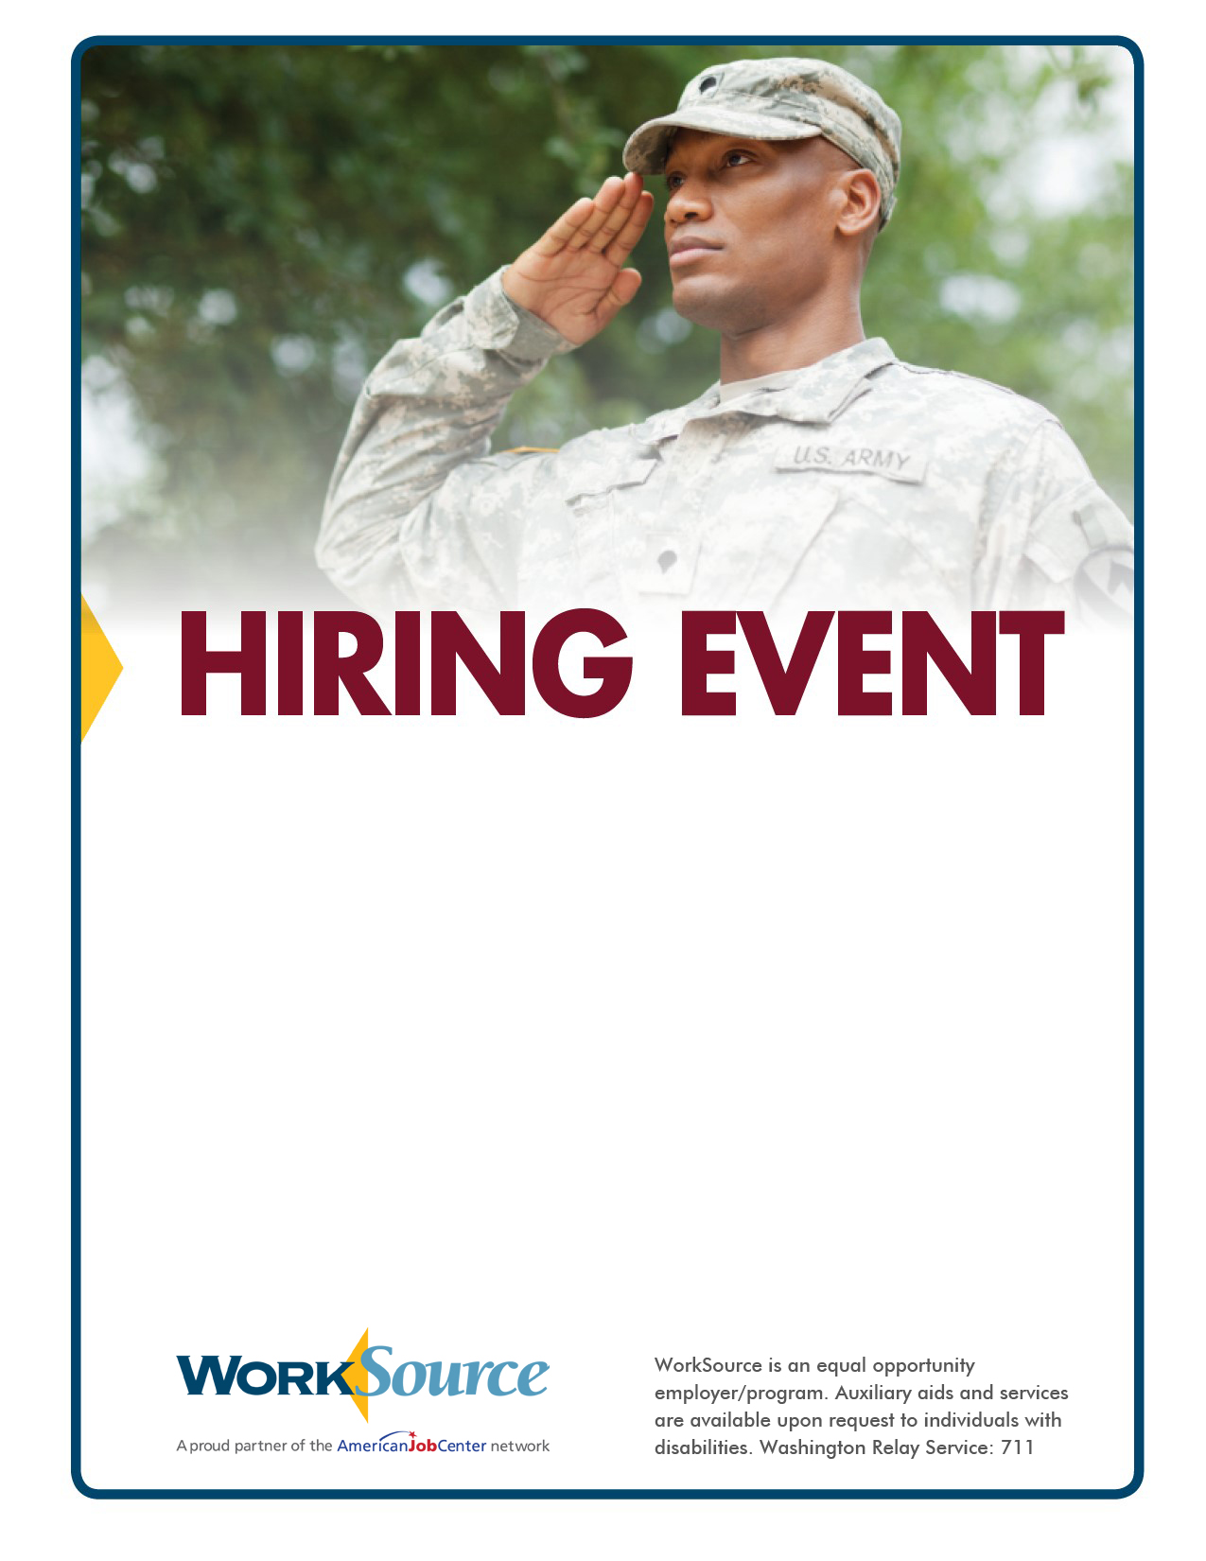

**February 15**

**1:30 p.m. to 3:30 p.m.**

**Admission is free!**

This event is open to the public.

Please bring your resume!

**Employers include:**

* Gary Merlino Construction
* Allied Universal Security
* Napa Auto Parts
* Teamplace Suites
* Horizon Air
* Capstone Logoistics
* Link Staffing and more…

**For more information contact:**

**Brian Culpepper**  
*Local Veterans’ Employment Represetnsative*   
**bculpepper@esd.wa.gov**

**WorkSource Auburn**

**2707 I Street N.E. Auburn**