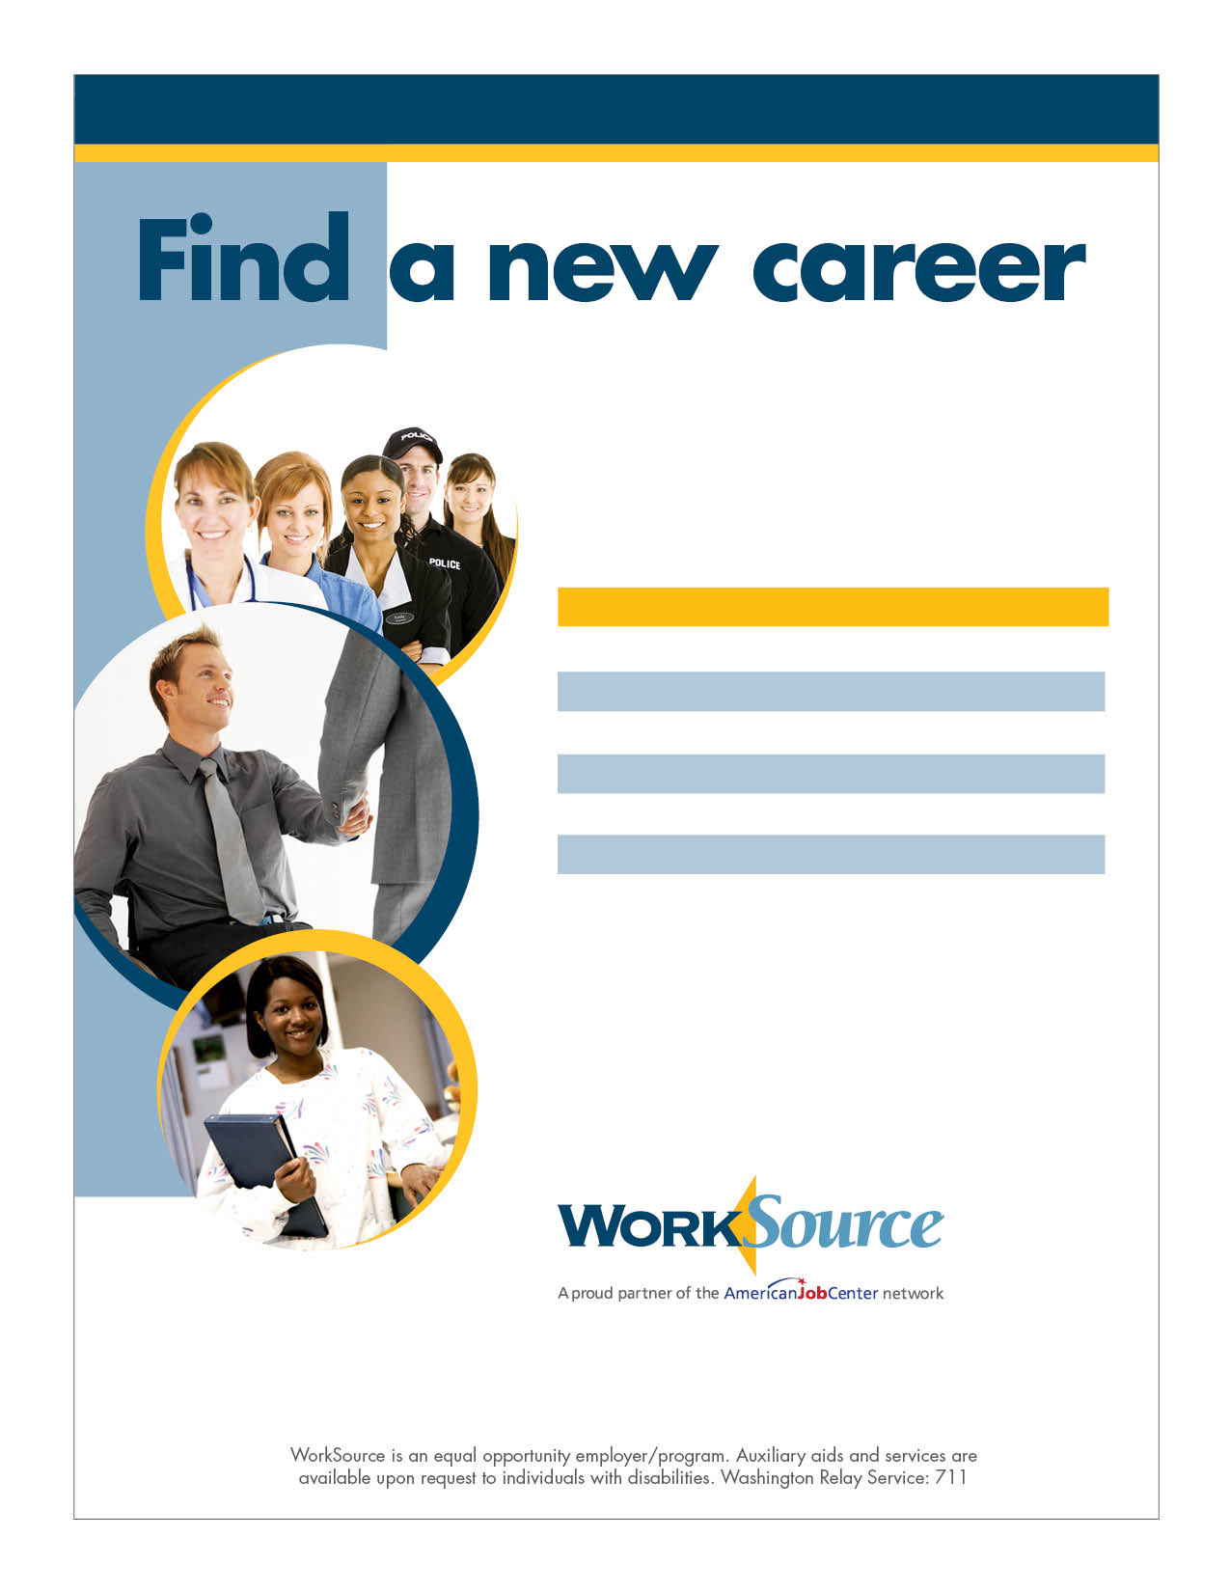

Join WorkSource Snohomish County for industry-specific job fairs:

DATE INDUSTRY Mar 23 Healthcare
May 4 Hospitality/Customer service
Jun 15 Apprenticeship/Manufacturing
Jul 13 Healthcare
Sep 14 Retail/Customer service
Nov 9 Veterans

All JOB FAIRS WILL BE HELD
10 a.m. to 2 p.m.

Everett Train Station
Weyerhaeuser room, fourth floor

3201 Smith Avenue I Everett, WA 98201
425-258-6300 or TTY 425-257-1217

