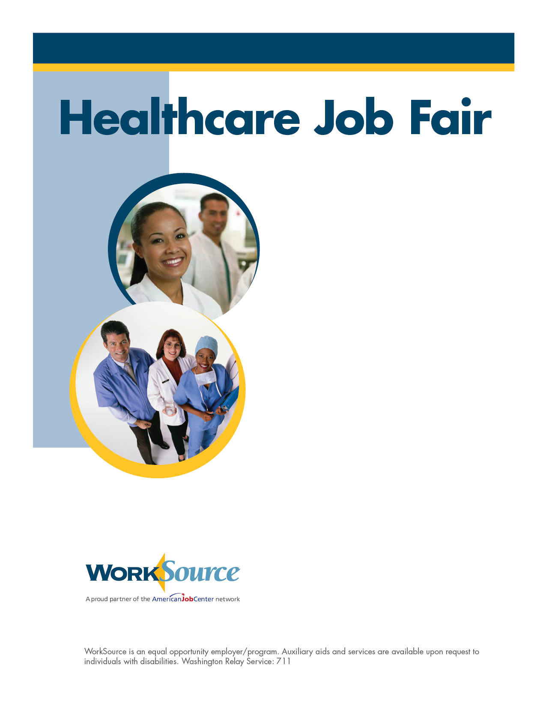

March 23
10 a.m. to 2 p.m.

WorkSource Everett
3201 Smith Ave
Fourth floor

Calling all businesses
with healthcare positions!

WorkSource is hosting a hiring event just for your company’s healthcare hiring needs.

Our extensive job-seeker inventory includes hundreds of people with healthcare experience.

Booth space is limited. Sign up by March 16.

For more information, contact
Carol Young at 425-673-3316.

