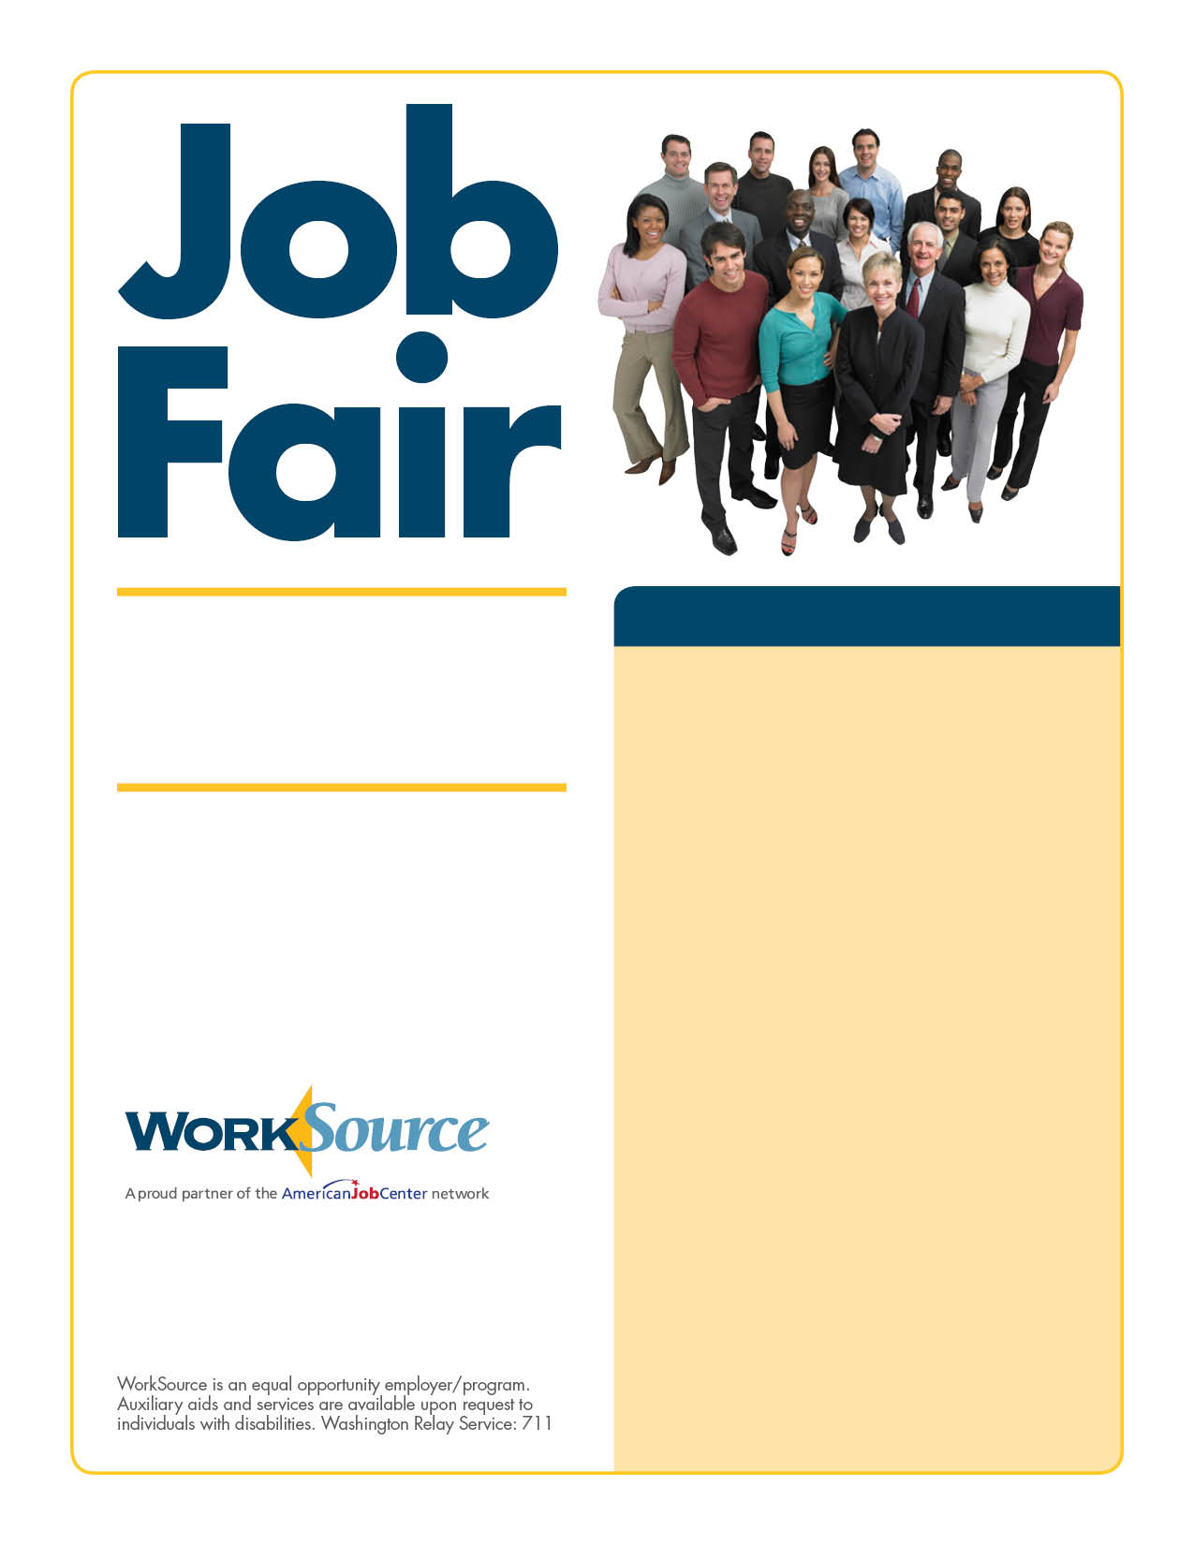

March 23
Partners
• Capital awards
• Office Max
• Great Wolf Lodge
• Safeway
• Olympia Federal Savings
• Washington State Department of Health
• Aflac
• ACS
• Cabelas
• Career Trek, Inc.
• Department of Social and Health Services
• Express Employment
• Kelly’s Services
• Capital Aeroporter
• Visiting Angels
• Washington State Employment Security Department
• Washington State Department of Revenue
• Pierce County Security/Pacific Coast
• Community Health Plan of Washington
• Washington State Department of Personnel
• Waste Connections, Inc.
• Lowe’s
• Smart Wireless (Sprint)
• Home Instead Senior Care
• Total Employment and Management
• Costco
• Manpower
• REI
• Lincoln Mercury

11 a.m. to 3 p.m.
Westfield Capital Mall

WorkSource and Westfield Capital
Mall are sponsoring a one-day job
fair, from 11 a.m. to 3 p.m.,
Wednesday, March 23. Bring your
résumé and be prepared to meet
with company representatives.

For more information, contact Kim Myers at
253-552-2547 or kmyers@esd.wa.gov

