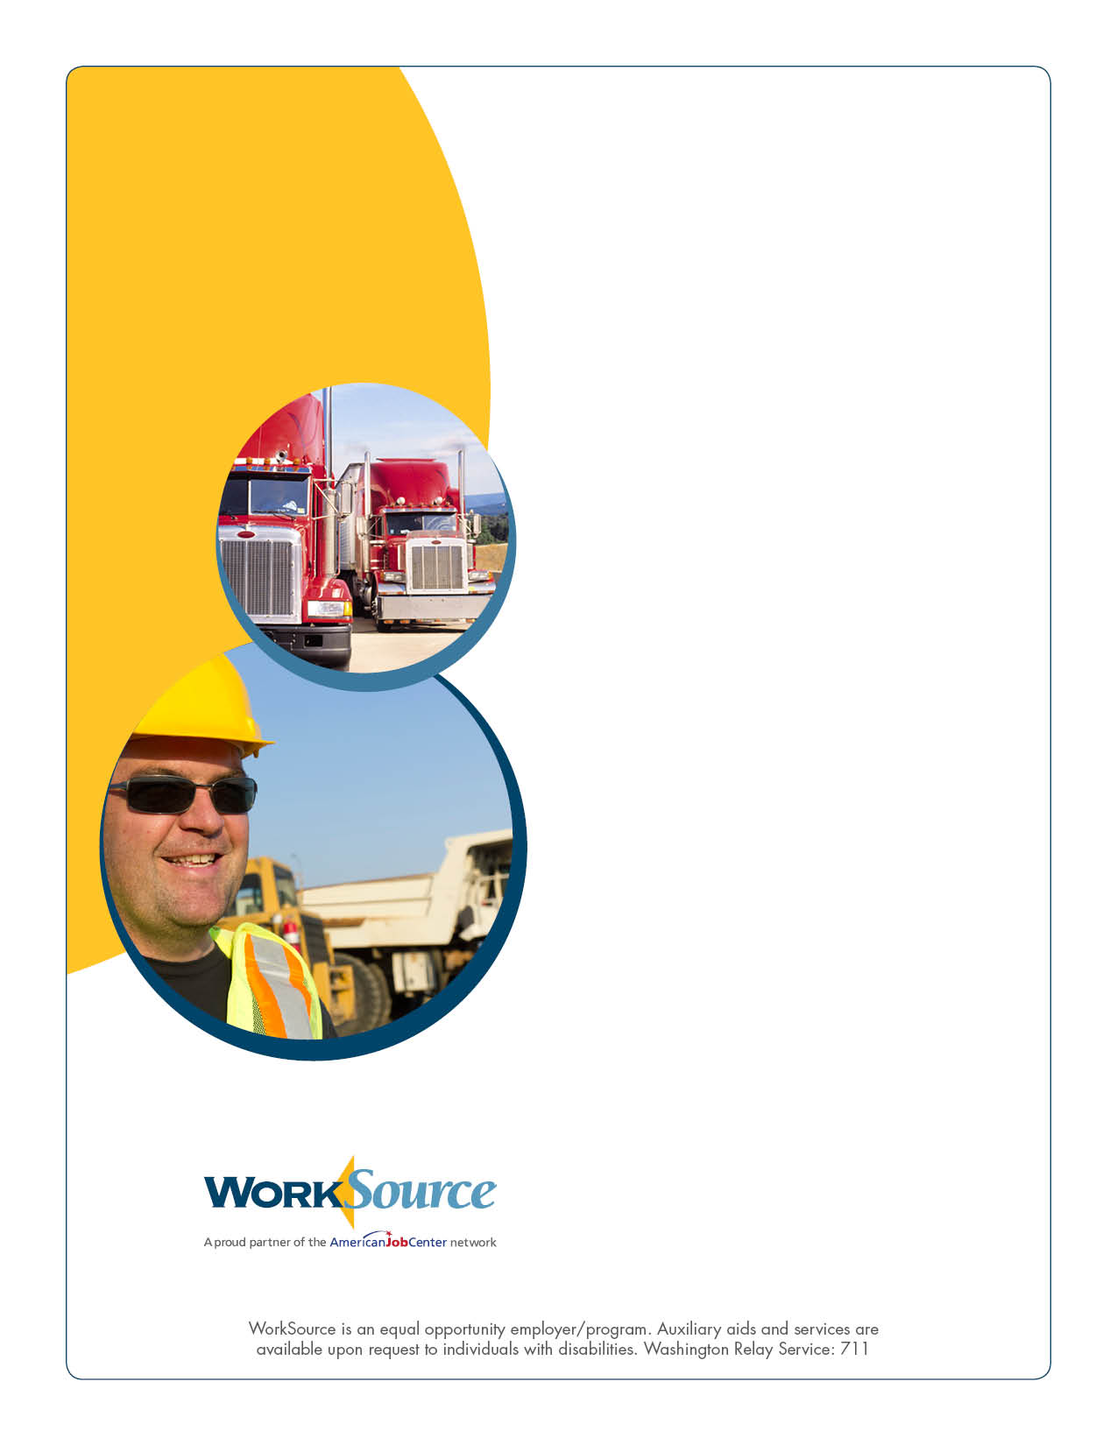
Transportation

Calling all businesses with transportation openings!

WorkSource is hosting a job fair to help with your recruiting needs. Come meet with applicants who are skilled and ready to work.

We also will have other job seekers at the fair who are ready to consider a transportation career.

June 13
9:30 a.m. to 1:30 p.m.

WorkSource Spokane
Redwood Room
130 S Arthur Street
Spokane

For more information, contact Dirk Vastrick at 509-532-3038
or dvastrick@esd.wa.gov.

